**Physiological and Genetic Identification of *Micrococcus luteus* Isolated from the Hind Foot of a Chinchilla**

Kjersten Williams

**Introduction**

The typical person is generally aware that microscopic lifeforms exist, that they populate the world around us, and are responsible for causing disease; however, not many people contemplate the fact that there are beneficial microbes or the fact that they inhabit our skin. The mammalian microbiome is extremely diverse, and varies with many factors, including location on or in the body, diet, and also age of the host. The microbiome of the skin is perhaps one of the most fascinating to study, as different locations on the body provide differing habitats as well as differing access to nutrients, allowing the microbial community of the skin to be extremely varied (Oh et al, 2014).

The term “microbe” is commonly interpreted with a negative connotation due to the fact that it is often thought to be synonymous with “pathogen” (a disease-causing microorganism), it is important to note that not all microbes are harmful. In fact, some microorganisms are even beneficial in certain environments. One such environment in which microbes function in a beneficial way is on the skin of humans and mammals alike, as “many of these microorganisms are harmless and in some cases provide vital functions that the… genome has not evolved. Symbiotic microorganisms occupy a wide range of skin niches and protect against invasion by more pathogenic or harmful organisms.” (Grice et al., 2011).

This lab project focused on the isolation, characterization, and identification of a single bacterial species from mammalian skin, more specifically the skin located on the underside of a pet chinchilla’s hind foot. In general, the folds and different compositions found on skin allow for the formation of different oxygenic and nutrient conditions by location, serving to provide an array of possible habitats for microbes depending upon their requirements (Garcia-Garcerã et al., 2013). Through physiologic testing and genomic sequencing, the isolate was identified as *Microccocus luteus*. This microbe has been found to be quite common on human skin, and has also been observed on the skin of mammals such as the tree shrew (Li et al., 2014). As the skin on the chinchilla’s foot provides a similar environment to that in which the microbe has previously been found, it makes sense that it would be found here.

**Methods**

In beginning my sample collection, I took two sterile cotton swabs moistened with sterile water and sampled the underside of my pet chinchilla’s hind foot. Using the cotton swab, I swabbed the pads as well as the recessed portions of the foot before streaking the swab over a Tryptic Soy Agar (TSA) plate. I repeated this process using another moistened sterile swab, streaking this one over a Sabouraud’s Agar (SA) plate. The TSA used was a complex agar commonly used in the growth of various microbes, while the SA was a medium known to be selective for the growth of fungi. I covered the plates, sealed them using Parafilm, and incubated both plates at room temperature. Within forty-eight hours of incubation, I observed minor growth in the form of small, circular, white colonies. By the sixth day of incubation, I noted that the TSA plate displayed growth of multiple types of bacteria, apparent in the presence of differently colored colonies, as well as a fungus in the form of a white, fibrous growth covering a portion of the plate surface. The SA plate displayed a more substantial occurrence of the same white, filamentous growth, indicative of the presence of a fungus.

I chose one of the white colonies on the original TSA plate and streaked it onto a new TSA plate using the Streak Plate Method described (Lab 2 Handout) in order to begin purifying the culture. This second isolate was then incubated at 37°C. I repeated this process three more times until I obtained a fourth isolate in which all colonies appeared consistent and uniform. This purification process was performed in an attempt to ensure that the culture was pure and the bacterium properly isolated in preparation for Gram staining.

I conducted a Gram-staining procedure according to the instructions provided (Lab 4 Handout), and then observed the microbe under a microscope to determine some of its characteristics, such as cell wall composition (Gram-positive or Gram-negative) as well as overall morphology. I then placed a sample of bacteria off of the TSA plate of the fourth isolate into Tryptic Soy Broth (TSB) to form a liquid culture of my bacterium in preparation for DNA extraction. Later, I made an observation of my isolate’s growth on the TSA plate which led me to perform further isolation and an additional gram stain.

I performed a DNA extraction from the isolate using the Powersoil DNA kit, and proceeded according to the steps and techniques described in the procedure (Lab 5 Handout), and also performed a fifth isolation of the microbe in preparation for physiological testing. The DNA extracted from my isolate was sent to the UAF DNA Core Lab, where a technician sequenced the DNA using the Illumina MiSeq technology. While awaiting the results of the sequencing, I performed multiple physiological tests on the isolated bacterium using the methods outlined (Lab 6 Handout). The tests I performed included a fluid thioglycollate test, to determine the microbe’s oxygen class, a catalase test, to determine if the microbe produced the enzyme catalase, and an oxidase test, to determine if the microbe produced the enzyme cytochrome *c* oxidase. In addition to these tests, I also performed tests inherent in a API 20E test strip, which was a testing aid composed of 20 separate wells, thereby enabling a researcher to simultaneously perform tests for the presence of several different enzymes, the fermentation of multiple sugars, and the utilization and production of different substances within the bacteria’s metabolic cycle. In performing the fluid thioglycollate and API 20E tests, a portion of the bacterium was placed into a medium (in the case of the fluid thioglycollate test, a sample of bacteria from the TSA plate was inserted into the fluid thioglycollate medium using a sterile plastic loop; in the instance of the API 20E test strip, a sample of the bacterium from the agar was mixed into a fluid medium and then pipetted into the wells of the test strip), and the medium was then incubated for five days. I incubated the fluid thioglycollate medium at room temperature and the test strip at 37°C. When I checked the tests after 48 hours of incubation, growth was still inadequate to draw conclusions from the tests. Following a total of five days of incubation, I deemed the growth adequate and made my observations of the microbe.

Once the raw genomic sequence data was provided by the UAF DNA Core Lab, I used this information to assemble the genome utilizing applications through BaseSpace, a website provided by Illumina; once portions of the genome were assembled using an application called SPAdes Genome Assembler, I used the assembled fragments to run further applications in an attempt to identify the microorganism. The three additional applications I ran using the data from the genomic sequencing of my isolate were: Kraken Metagenomics, Prokka Genome Annotation, GENIUS Metagenomics, and the BLAST program. The Kraken and GENIUS Metagenomics applications tried to determine the identity of the isolate by matching the assembled genomic sequence fragments to known sequences within the database, while the Prokka Genome Annotation application identified specific genes for which the coding and function were known. While only the Kraken Metagenomics and Prokka Genome Annotation applications were required by the lab protocol (Lab 7 Handout), I utilized the GENIUS Metagenomics application due to the fact that the Kraken application did not report a high percentage of classified reads with which to confidently identify the microbe. While the GENIUS Metagenomics provided a higher percentage of classifications, this percentage was still lower than that which is accepted as representative of a confident result (>80%). I therefore decided to also run the sequences using the BLAST program, which returned confident results identifying the bacteria contained in my sample.

The final test I ran on my isolate was an antibiotic susceptibility test. For this test, I used a sterile cotton swab to gather a portion of the TSB culture of my isolate and smear it over two TSA plates. Four antibiotic disks, one for each of the eight antibiotics being tested against the microbe, were then placed on the TSA plates, and incubated at 37°C for two days. On the second day, plates were examined for both bacterial growth and possible zones of inhibition around the antibiotic disks. The diameter of these zones, as measured in millimeters, indicates the level of susceptibility of the isolated microbe to a particular antibiotic substance.

**Results**

Upon performing multiple streaks on TSA in an attempt to purify the mixed bacterial sample, the culture presented as uniform, circular, white, raised, small and moderately sized colonies with entire borders (Figure 1); these colonies displayed a shine when tilted to the light. Upon observation of the sample following the initial Gram-staining, I noted that the culture contained a mixture of both Gram-positive and Gram-negative bacteria, formed into clusters, which had the appearance of both cocci and rods respectively; there were also what appeared to be yellow fibers present, the source of which is unknown (Figure 2). Later, I noted a variance in colony pigmentation in one of my isolate streak plates which had been incubated at 4°C for approximately one month: some colonies remained white in appearance while others had developed more of a yellow pigmentation (Figure 3). Upon making this observation, I decided to perform another isolation, aiming to isolate the colonies which had maintained a light coloration; this resulted in a streak plate with only white colonies (Figure 4). I performed an additional Gram stain from this plate in order to determine whether or not the microbe had finally been truly isolated. Examining the stain through the microscope, I observed only Gram-positive, small coccus-shaped, cluster-forming bacteria, indicating that I had finally isolated my microbe (Figure 5).

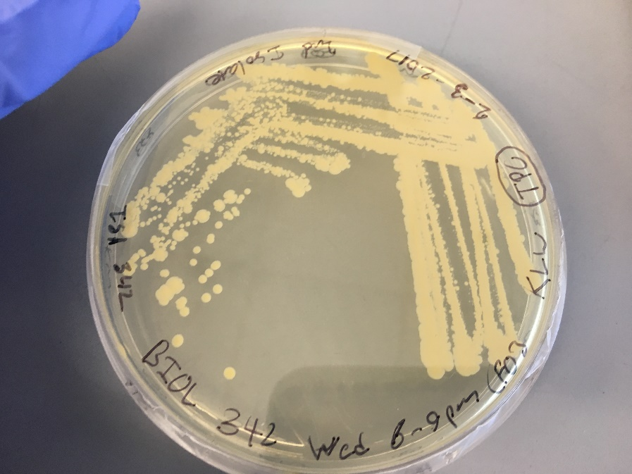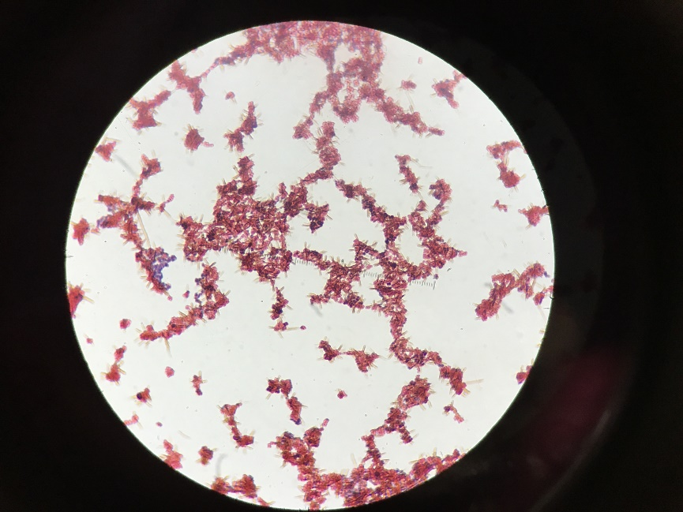

**Figure 1**. One of the initial streaks of isolate. **Figure 2**. Gram stain of mixed culture isolate.

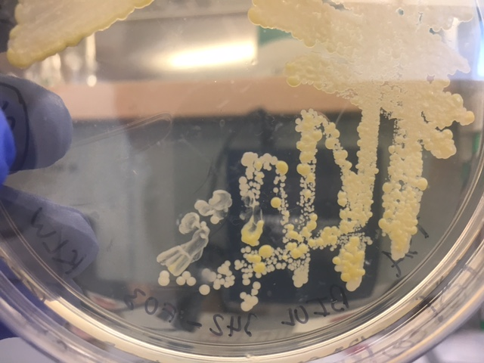

**Figure 3**. Culture pigment differentiation

following prolonged incubation at 4°C.

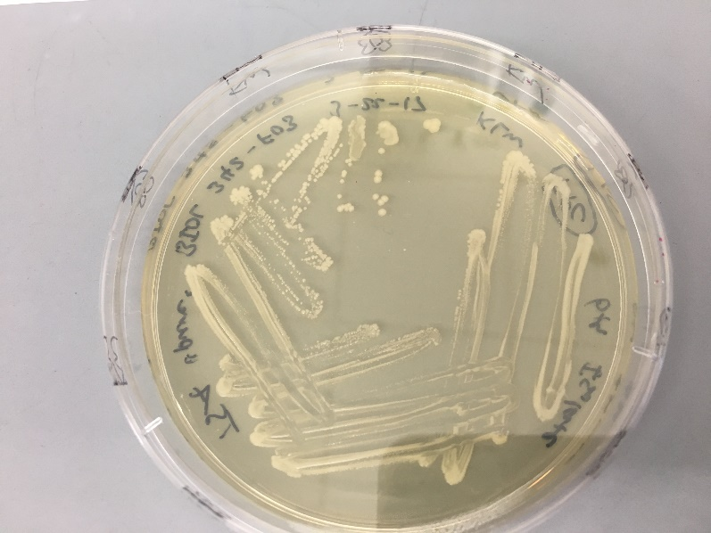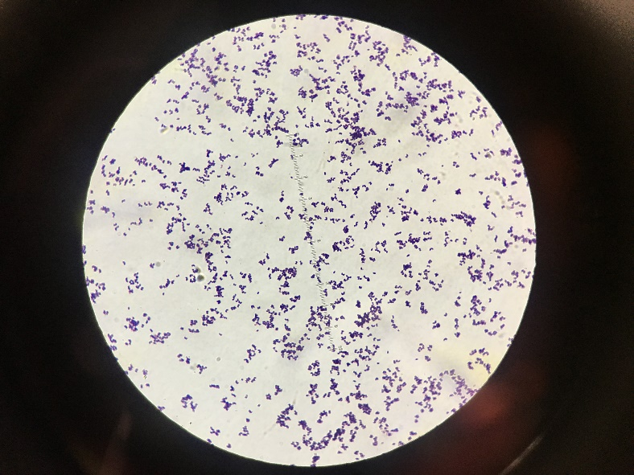

**Figure 4**. Pure culture on TSA. **Figure 5**. Pure culture Gram stain of *M. luteus*.

I performed physiological testing on my sample, the complete details of which can be found in the tables below (Tables 1 & 2). The fluid thioglycollate test resulted in a high concentration of bacterial growth near or just below the surface of the medium, indicating that the microbe is a strict aerobe. My sample tested positive for catalase, indicating my isolate’s production of this enzyme, and tested negative in the oxidase test, indicating that it does not produce cytochrome c oxidase. The sample tested negative to the majority of physiological tests contained in both the API 20E and the API Staph testing strips (Table 1), save for the tests labeled URE and GEL, indicating that the bacterium contained in my sample cannot ferment any of the sugars in these testing kits, and cannot break down or utilize the majority of the other substances tested. It can, however, produce the enzymes urease and gelatinase which break down urea and gelatin, respectively.

Upon complete sequencing and analysis of the genomic sequences extracted from the bacterial DNA of my culture, 1 species and two bacterial genera were identified: *Micrococcus luteus*, *Brevibacterium spp.*, and *Corynebacterium spp.* The initial results received for my isolate from Krona Metagenomics can be observed in Figure 6 below; note that this program did not display the presence of the other two genera in the culture. From the assembly of my isolate genome, I received 662 contigs (>1000bp), the longest of which was 209,694pb; the program also found that my isolate genome had 5,570 coding regions. Three of the functional genes found in the bacterial genome were: KsdD-like steroid dehydrogenase MSMEG_5835 (able to catalyze the elimination of part of a ring on 3-ketosteroids), universal stress protein/MT2061 (which functions to protect the organism during times of environmental stress), and NAD(P)H-dependent FAD/FMN reductase (which is involved in the pathway of tryptophan degradation, reducing FAD/FMN to FAD $H_{2}$/FMN $H_{2}$ so that they can then be used in the hydroxylation of anthranilate).

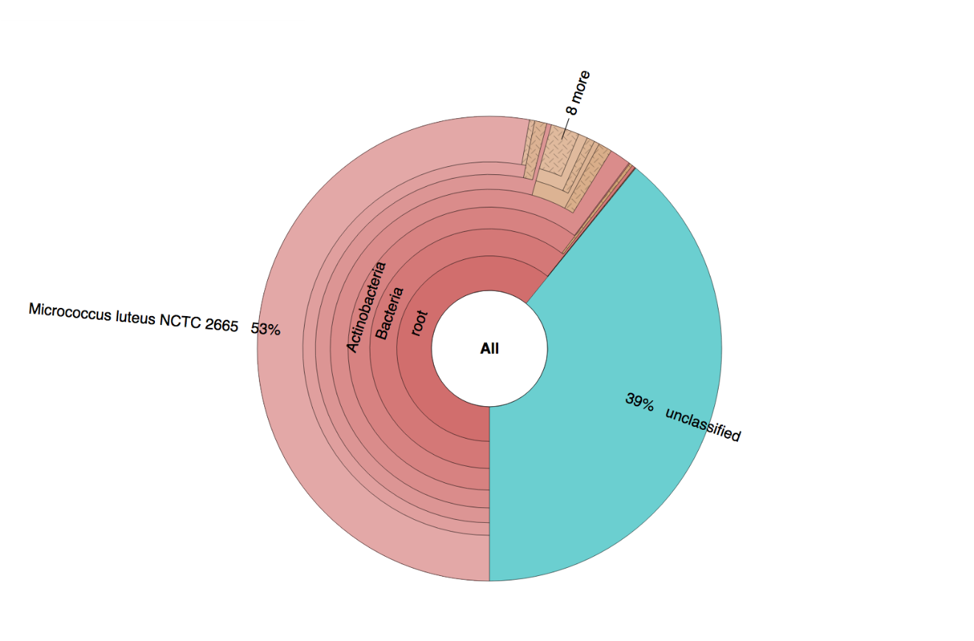

**Figure 6**. Krona Metagenomics results

I also performed an antibiotic susceptibility test on my isolate, in which I tested my isolate against eight antibiotics. I observed zones of inhibition around 7 of the 8 antibiotic discs. The diameters of these zones as well as the indicated level of susceptibility that these measurements represent are recorded in Table 2 below. The one antibiotic around which a zone of inhibition was completely absent was Trimethoprim, thus indicating that my microbe is highly resistant to it.

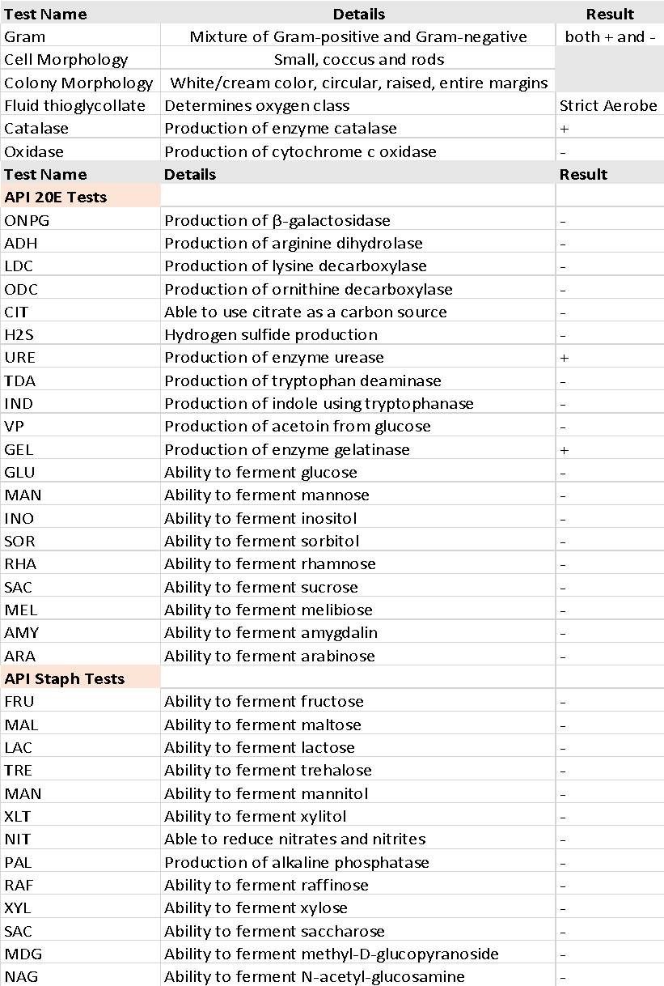

**Table 1**. Results of tests used in identification of the isolated bacterium. Note that some

tests in API 20E were replicated in API Staph, but the repeated recording of their consistent

negative result was not included in the table.



**Table 2**. Results of antibiotic susceptibility tests.

**Discussion**

Concerning the physical appearance of my isolate, the appearance of colonies grown on the TSA plate were consistent with the literature concerning *Micrococcus luteus*; the results of my first Gram-stain, however, were somewhat atypical. In accordance with the literature concerning the presentation of *M. luteus* (Kloos et al., 1974), my sample did present as a Gram-variable cocci under microscopic observation; however, the sample overall appeared Gram-negative with only a small portion of Gram-positive cells intermixed. I believe this mostly Gram-negative appearance was primarily due to overexposure of the stained sample to ethanol during the Gram-staining process; such an error would remove the purple stain of the crystal violet and leave both Gram-positive as well as Gram-negative cells with the red coloration imparted by the safranin in the final steps of the procedure. The differences in bacterial shape and the yellow fibers observed, are all aspects which indicate the likely presence of contamination within the sample. Further isolation through another streak plate employing pure culture technique and observation of the culture through a microscope following a second Gram stain revealed a newly purified culture of *M. luteus* in the form of small, Gram-positive, cluster-forming cocci, with no other morphologies or Gram types present.

The physiological testing of my isolate agreed with the results of previous physiological testing on the bacterium *Micrococcus luteus* as noted in published literature: it appeared catalase and urease positive, tested negative for the fermentation of various sugars (Fischer-Colbrie et al., 2007), and also tested as a strict aerobe (Kloos et al., 1974). However, there were a few areas in which the physiological testing did not agree with the genomic identification. The isolate tested negative for both nitrate reduction and for the production of oxidase, while testing positive for the production of gelatinase, an enzyme not associated as being produced by this bacterial species. Concerning the negative result from the oxidase test, I suspect that this negative result was due either to an inadequate amount of sample applied to the test strip or injected into the nitrate testing well on the API strip, the test strip being old, or contamination of the sample with other bacteria; further testing would be required to determine the specific cause of these results. The production of gelatinase for which the culture tested positive is resolved by examination of the analysis for the partial bacterial genome was extracted from my sample.

Following multiple attempts to identify the isolate from its partial genome using the bioinformatics software applications provided by Illumina, the genomic sample was determined to be primarily a mixture of three types of bacteria: *M. luteus* was determined to be one of the most abundant species, while also present in significant measures were *Brevibacterium spp.* as well as *Corynebacterium spp*. The presence of these genera in the culture would account for the discrepancy in bacterial shape observed in the initial Gram-stain of the isolate. *Brevibacterium spp.* have been known to vary in shape between rod and coccus form depending upon the age of the cells (Gruner et al., 1993); meanwhile, *Corynebacterium spp.* have been classified as bacillus, but have also been known to potentially display a an irregular bacillus shape resembling a club. *Brevibacterium spp.* are known to produce the enzyme gelatinase, thereby explaining the positive test result for the presence of this enzyme in my culture.

I also performed antibiotic resistance tests on my isolate, testing it against eight different antibiotics. The culture tested susceptible to all antibiotics except for Trimethoprim, to which it tested highly resistant as displayed by the absence of a zone of inhibition surrounding this antibiotic disc. These results concur with the literature, as it has been reported that *M. luteus* is generally susceptible to most antibiotics, specifically the Clindamycin and Gentamicin involved in this test (Bannerman & Peacock, 2007). I note that Trimethoprim is also the only antibiotic tested against the isolate which works by inhibiting DNA synthesis, while the other antibiotics inhibited other processes such as protein and cell wall synthesis.

Taking into account the results of the testing performed on my culture throughout this experiment, I would say that the physiological results concur with the bioinformatics data concerning the different genera of bacteria present. Physiological characteristics of *M. luteus*, *Brevibacterium spp.*, and also *Corynebacterium spp.* are all represented in the information I have gathered on my culture. Given the preferred habitat and shared characteristics of these three types of microbes (Gram-positive, catalase-positive, aerobes, generally innocuous to the host, etc.) it is not surprising that they would be found to thrive on the pad of a mammalian foot. More research would be necessary to develop more efficient methods for gaining pure cultures of each of these microbes so that each of their particular traits can be more fully understood.

References

Bannerman, T. L., & Peacock, S. J. (2007). Staphylococcus, Micrococcus, and Other Catalase-

Positive Cocci. *Manual of Clinical Microbiology*. 9th ed. 390-404. Washington, USA:

ASM Press.

Fischer-Colbrie, G., Matama, T., Heumann, S., Martinkova, L., Paulo, A.C., and Guebitz, G.

(2007). Surface Hydrolysis of Polyacrylonitrile with Nitrile Hydrolysing Enzymes from

Micrococcus Luteus BST20. *Journal of Biotechnology* 129(1), 62-68.

Garcia-Garcera , M., Garcia-Etxebarria, K., Coscolla , M., Latorre, A., and Calafell, F. (2013). A

New Method for Extracting Skin Microbes Allows Metagenomic Analysis of Whole-

Deep Skin. *PLOS ONE* 8(9), 1-12.

Grice, E. A., & Segre, J. A. (2011). The skin microbiome. *Nature Reviews Microbiology*, 9(4),

244-253.

Gruner, E., Pfyffer, G.E., and Von Graevenitz. A. (1993). Characterization of Brevibacterium

Spp. from Clinical Specimens. *Journal of Clinical Microbiology,* 31(6), 1408-412.

Kloos, W. E., Tornabene, T.G., and Schleifer, K. H. (1974). Isolation and Characterization of

Micrococci From Human Skin, Including Two New Species: Micrococcus Lylae and

Micrococcus Kristinae. *International Journal of Systematic Bacteriology* 24(1), 79-101.

Li, G., Lai, R., Duan, G., Lyu, L., Zhang, Z., Liu, H., Xiang, X. (2014). Isolation and

identification of symbiotic bacteria from the skin, mouth, and rectum of wild and captive

tree shrews. *Zoological Research* 35(6). 492−499.

Oh, J., Byrd, A.L., Deming, C., Conlan, S., Barnabas, B., Blakesley, R., Bouffard, G., Brooks,

S., Coleman, H., Dekhtyar, M., Gregory, M., Guan, X., Gupta, J., Han, J., Ho, S.,

Legaspi, R., Maduro, Q., Masiello, C., Maskeri, B., Mcdowell, J., Montemayor, C., Mullikin, J., Park, M., Riebow, N., Schandler, K., Schmidt, B., Sison, C., Stantripop, M., Thomas, J., Thomas, P., Vemulapalli, M., Young, A., Kong, H.H., and Segre, J.A. (2014). Biogeography and Individuality Shape Function in the Human Skin Metagenome. *Nature*, 514(7520), 59-64.