Rod Espejo
Microbiology
Mary Beth Leigh
April 26, 2017
Finding Micrococcus luteus Inside A Forsaken Old Boot
Introduction
Microbial organisms can be found everywhere. From the surfaces of tables, on human skin, submerged in puddles of water, to extreme environments (inside volcanoes, for example). Microbes seem to be versatile enough to be able to survive virtually anywhere on Earth so long as conditions of a particular environment meet the requirements of their metabolic lifestyle. Microbes do not just pick environments that are extreme or exposed to the elements, but they could also thrive in places that are common, ordinary, and secluded.
Houses are microscopically teeming with life, regardless of how many times they get cleaned on a daily basis by their inhabitants. Thus, it was no surprise that Micrococcus luteus had been thriving inside a crusty old boot, which had been neglected inside a coat closet for several years.
The inside of a shoe is not an uncommon setting for a bacterial strain like M. luteus to settle in. Bacteria thrives where it is moist, dark, and warm, and shoes have been known to harbor massive amounts of bacteria not just from the outside, but also from the inside. One thing to note here is that M. luteus is commonly found on moist areas of the skin, such as the armpits or, more importantly, between the toes.
Dr. Charles Gerba, a professor and microbiologist at the University of Arizona, and Jonathan Sexton, a research specialist, conducted a study on how much bacteria a shoe can accumulate. Within two weeks, the shoes have gathered an average of 421,000 units of bacteria, both inside and outside combined (Gallant).
The aim for this paper is to explain and evaluate the process of how Micrococcus luteus had been isolated, characterized, and identified inside the boot in question. In order to achieve this, physiological and genetic tests had to be conducted and analyzed carefully in order to reach a satisfying and plausible conclusion.
Methods
I collected a sample of bacteria inside an old boot found in a coat closet using an aseptic swab dipped in a small, vial of sterile water. The sample was, then, contained in a Tryptic Soy Agar (TSA) plate. Sealing the plate with parafilm, I stored it in a safe location, free of risk of disturbance and at room temperature for about 48 to 72 hours.
After learning and familiarizing myself with culturing techniques, such as the quadrant streak in Lab 2, I picked one isolated colony from my TSA plate and streaked it onto a new one for the purpose of isolating a pure culture. I streaked a number of new plates over the course of several weeks to obtain a pure isolate of my bacteria. After each streak, we incubated the plates at 37°C, and then moved them to the refrigerator to prevent them from growing too quickly.
In order to identify the bacteria, I started with classifying whether or not my isolate was Gram-positive or Gram-negative. Gram-positive stains purple, while Gram-negative bacteria stains pink or red. In order to figure out which one my isolate identifies with, I viewed a Gram-positive and Gram-negative bacteria under a microscope and compared it to what my isolate looked like.
Next, during Lab 5, I was tasked with extracting DNA from my bacterial strain, which was sent to the UAF Core Lab Technician so they could analyze the DNA and sequence the whole genome of the sample. I extracted the DNA via the Mobio PowerSoil DNA kit, which lysed the microbial cells, removed their inhibitors and proteins, and extracted a solution of pure DNA. Centrifuging the solutions at the fastest setting, creating a supernatant solution, and incubating them in ice baths for several minutes allowed me to produce a DNA solution used for further identification of my bacterial isolate.
I conducted physiological tests on my project isolate, as well. I went through the fluid thioglycollate test first, which gave me an idea of the bacteria’s oxygen class. I utilized a special stab technique into a tube of soft agar that had an oxic zone near the top and an anoxic zone in its middle and bottom parts. These zones would help clarify if my bacterium is either an aerobic or anaerobic microorganism, or perhaps a bit of both.
The catalase test, which showcases whether or not a bacterial strain contains the enzyme of the same name and indicates whether or not the bacteria uses oxygen as an electron acceptor, was performed afterwards. I administered this test by depositing a droplet of Hydrogen peroxide (H₂O₂) onto a smear of my isolate. Bubbling of the smear indicates that the strain has accepted O₂ as its electron acceptor. In short, that would be considered a positive result.
To figure out whether or not my bacterial isolate possessed the cytochrome c oxidase enzyme, I carried out the oxidase test. Using aseptic technique, which we learned back in lab 2, I smeared a small sample onto a thin oxidase test strip. Purple indicates a positive result, and a yellowish color indicates a negative outcome.
Last but not the least for the physiological tests, I inoculated the API 20E test strip to help identify the bacteria. This is an expensive kit that contains 21 mini-physiological tests. Unlike the previous three tests mentioned above, this set of tests is a little vague on its description and purpose. According to the Lab 6 manual, these particular sets of tests help “distinguish between different species within major groups.”
In Lab 7, we received back our genome sequences from the UAF Core Lab technician. Prior, we registered an account for the Illumina Base Space program so we all could run analyses on the whole genome sequences in order to finally determine the most likely identity of our bacterial isolates. This process is called Bioinformatics.
Using the SPAdes Genome Assembler, like the name implies, I assembled the genome of my isolate. This program told me how many contigs—overlapping DNA fragments that represent together a consensus region of DNA—I had in my genome, as well as my GC (guanine and cytosine) percentage, among other things.
The Kraken Metagenomics program of Base Space discerned my isolate to the genus and/or species level. Running the program also shows charts and other useful visuals that help solidify the identity of the pure isolated colony. Afterwards, I ran the Functional Gene Annotation that recognizes the genes in the genome so I could determine them and explain how those genes work to help the bacteria function as a whole.
During lab 9, I tested seven antibiotic tablets against my bacterial strain in order to test its antibiotic susceptibility (or resistance properties). I divided the seven tablets into two agar plates (both streaked with a bacterial lawn): plate one with three tablets and plate two with four tablets. Plate one contained oxacillin, tetracycline, and erythromycin, while plate two had vancomycin, gentamicin, amikacin, and cefazolin.
To increase confidence for my results, I copied M. luteus’ whole genome sequence and entered it on the BLAST website. This website compared my data to a known database, giving the results a confidence level by way of percentages.
All of these tests helped drive forward the narrative of finding out the identity of the bacterial strain I had swabbed from an abandoned boot, which was exciting enough to see unfold.
Results
The isolate from the boot in question—when viewed under the microscope at 100X magnification with oil immersion—turned out purple, meaning that it is a Gram-positive bacterium. The colonies were in clusters instead of individually spaced, and they were rod-shaped.
I exposed my bacteria to a variety of physiological tests that provided important insight into its metabolic capabilities. The fluid thioglycollate test revealed that my culture is a facultative anaerobe, which means that it could perform anaerobic metabolism despite being aerobic in nature.
It was also revealed that the enzyme catalase was present in my culture. Vivid bubbling occurred when a drop of hydrogen peroxide made contact with a smear of my bacteria; the isolate was positive. This is called the catalase test.
The oxidase test was also positive, indicating that the culture contains the enzyme cytochrome c oxidase.
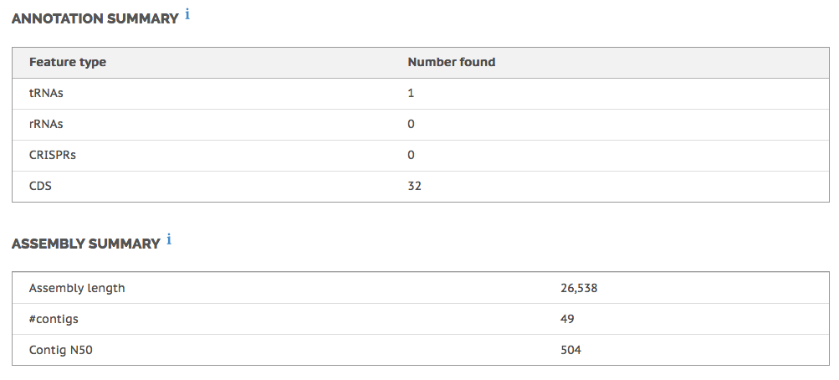
Figure 1. Prokka Genome Annotation. This table revealed how many tRNAs, rRNAs, etc., was present in the DNA sample that we sent to the UAF Core Lab Technician.

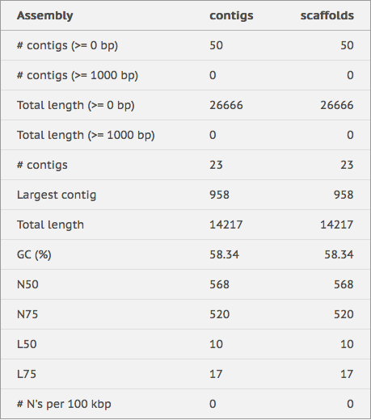
Figure 2. SPAdes Genome Assembler. This table shows various results from the DNA sample of our bacterial isolate, including G+C content percentage, number of contigs in our whole genome and its total length.
After the DNA sequences for my isolate came back from the UAF Core Lab technician, and after analyzing it through BaseSpace, the taxonomic data yielded from the bioinformatics programs used produced inconclusive outcomes. The data simply lacked the minimal numbers required in order to give more of a definitive conclusion about the isolate. However, the Prokka Genome Annotation program was able to show me at least one functional gene that my isolate possessed. The functional gene shown was a universal stress protein A, which allowed my organism to cope with a variety of environmental stressors and gave it a better chance to survive by adaptation.
Copying the whole genome sequence onto a program called BLAST, my bacterial isolate was identified—with a “Query Cover” of about 42%—to be Micrococcus luteus, a fairly common strain of bacteria. Kocuria rhizophila is also another name for this strain (Morgulis et al., 2008).
M. luteus appeared to be mostly susceptible to the antibiotics that were tested against it in the lab. Over the total antibiotics used, the isolate was 57% susceptible and 43% resistant. It was very susceptible to tetracycline, vancomycin, amikacin, and cefazolin. On the other hand, it had resisted the effects of oxacillin, erythromycin, and gentamicin.
Discussion
According to Kloos and Musselwhite (1975), the microorganism Micrococcus luteus can be predominantly found and isolated from human skin. There, they break up compounds in sweat that in turn produces an odorous scent (MicrobeWiki). Considering where the bacterial sample originated from, a forsaken boot, the revelation was not at all surprising, as it does come into contact with human skin. The surprising issue was the inconsistencies that arose from the test results that did not completely adhere to the preexisting knowledge of this certain bacterium.
Micrococcus luteus is an obligate aerobe, meaning that it cannot survive without the presence of oxygen (Young et al., 2010). However, my findings with the fluid thioglycollate test have shown minimal growth all over the anoxic region of the soft agar tube and a heavier growth on the surface, implying a facultative anaerobic mechanism. The error could be explained by the possibility that the culture was impure when the soft agar was inoculated with the bacterial sample. A more anaerobic microbe could have contaminated the sample and was mixed in, and thus the fluid thioglycollate soft agar tube had merely reflected that outcome. Another possibility would be that during the time of inoculating the tube, oxygen had been introduced to the anoxic region, resulting in my isolate following that “oxygen trail.”
The catalase test, on the other hand, supported what is found in the literature and was positive for my isolate, which indicated that the bacterial strain had accepted O₂ as an electron acceptor when coupled with hydrogen peroxide. The catalase enzyme is usually considered protection against reactive oxygen species, and that it “detoxifies hydrogen peroxide” (Madigan et al., 2014). Another test that turned out positive was the oxidase test that tests for the enzyme cytochrome c oxidase. The presence of the enzyme meant that my bacterial strain possessed an Electron Transport Chain (ETC), inferring that it is capable of aerobic respiration. This result seemed to match with the oxygen class identification of my isolate.
The genetic results did not turn out as well as expected. The data from the SPAdes Genome Assembler was lacking, since the number of contigs should have easily been in the hundreds, whereas my results yielded enough data to identify a taxonomic ID but not enough for a complete analysis. To check what tRNAs my isolate had, the Prokka Genome Annotation also did not yield substantial, useful outcome. It had only detected one functional gene, the universal stress protein A. This could have been caused by many factors. The step that is the most likely the cause of low quality results from sequencing is the DNA extraction. Possibly it was due to human error or there was just not enough of the isolate to extract DNA from, and so the analysis of its whole genome sequence lacked vital information.
The antibiotic susceptibility tests provided information that was telling of its microbial subject, yet not without its slight complications, so to speak. As mentioned in the results sections above, the isolate was mostly susceptible to antibiotics tested in the lab except a few, such as oxacillin, erythromycin, and gentamicin. Nevertheless, based on data provided by the Public Health Agency of Canada, M. luteus was supposedly susceptible to the antibiotic gentamicin (2011). My results, on the other hand, differed in that it absolutely resisted the effects of that particular antibiotic. It also resisted erythromycin, which was widely known and predictable, but its resistance against gentamicin was a result I did not expect. It could mean that somehow my isolate had already developed a resistance against it despite the short exposure time, but that scenario poses a question as to the amount of time it actually takes for a microorganism like M. luteus to develop a resistance against an antibiotic like gentamicin. Perhaps it depends on the temperature as well as the properties of the bacteria itself.
The bacterial strain I sampled proved to be an intriguing microorganism to observe and research. In spite of the inconsistencies of my lab results, the identification of M. luteus was a fruitful and illuminating endeavor. Like the titular forsaken old boot, the bacterial isolate sat silently over the years in that one corner of the coat closet. There, it thrived amongst a microbial community that preferred the dark, lonely, quiet corner. In truth, there was no need to swab the boot for microbes in the first place. The scent was a dead giveaway: a true mark of bacteria, even if you can’t physically see them.
References
Aleksandr Morgulis, George Coulouris, Yan Raytselis, Thomas L. Madden, Richa Agarwala, Alejandro A. Schäffer (2008), "Database Indexing for Production MegaBLAST Searches", Bioinformatics 24:1757-1764.
Gallant, Courtney. "Petri Dishes You Can Wear: UA Researchers Study the Bacteria on the Bottoms of Your Shoes." The Daily Wildcat. University of Arizona, 15 Sept. 2016. Web. 26 Apr. 2017.
Government of Canada, Public Health Agency of Canada. "Micrococcus - Public Health Agency of Canada." Micrococcus - Public Health Agency of Canada. Public Health Agency of Canada, 19 Apr. 2011. Web. 11 Apr. 2017.
Kloos, Wesley E., and M. S. Musselwhite. "Distribution and persistence of Staphylococcus and Micrococcus species and other aerobic bacteria on human skin." Applied microbiology 30.3 (1975): 381-395.
Madigan, Michael T., K. S. Bender, D. H. Buckley, W. M. Sattley, and D. A. Stahl. Brock Biology of Microorganisms. NY, NY: Pearson, 2014. Print.
"Microccocus." MicrobeWiki. Kenyon College, n.d. Web. 10 Apr. 2017.
Young, Michael, V. Artsatbanov, H. R. Beller, G. Chandra, K. F. Chater, L. G. Dover, E. Goh, T. Kahan, A. S. Kaprelyants, N. Kyrpides, A. Lapidus, S. R. Lowry, A. Lykidis, J. Mahillon, V. Markowitz, K. Mavromatis, G. V. Mukamolova, A. Oren, J. Stefan Rokem, M. C. M. Smith, D. I. Young, and C. L. Greenblatt. "Genome Sequence of the Fleming Strain of Micrococcus luteus, a Simple Free- Living Actinobacterium." Journal of Bacteriology. American Society for Microbiology (ASM), Feb. 2010. Web. 10 Apr. 2017.

