Biology 342 F01
Rachel Alexander
The Identification and Classification of Staphylococcus Epidermidis, isolated from a Dog’s Mouth
Introduction
This project was set up to help isolate a strain of bacteria from a specific place from everyday life. Everyone grew up knowing that microbes are everywhere and by looking at the microbe’s specific characteristic we can determine what it is and see why it lives in the environment that as sampled.
Staphylococcus Epidermidis is usually a non-parthenogenetic strain of staph that is typical of most skin bearing creatures. This gram positive strain is known for the formation of biofilms that grow more rapidly in people with suppressed immune systems particularly in patients with surgical implants (O’Gara, Humphreys 2001). It is interesting the see that a strain of staph can be found in a healthy dog’s mouth without making the dog sick or cause the dog any harm while he is still healthy.

Methods

Sample Collection and Initial Isolation
In order to collect a sample from a canine’s mouth a sterile swab was inserted into its mouth and run along the inside of the cheek. The swab was then run along the agar of a TSA (tryptic soy agar) plate as well as a SA. The culture was allowed to grow in a dry, warm environment for one week. After the colony was visible a single colony was quadrant streaked onto another TSA plate.

Pure Culture Techniques and Isolating Bacterium
This streaking process was repeated until the bacterial colony appeared to be completely uniform and consistent over a several week period.

Characterization and Identification
The first step in identifying what strain of bacteria was isolated was gram strain. A slide was prepared by placing a small sample of isolate on a slide and allowed to dry. A gram stain was performed in order to determine if the isolated bacteria was gram positive or negative and this information was used to help identify the strain.
16S rRNA gene sequencing
Our isolated samples were sent off to a company, Illumina Sequencing, and they provided a lot of information from number of contigs, to percent confidence of the specific genes present
from the sequenced data. This data was used to positively identify the specific strain of bacteria isolated from the canines mouth.
Results
The results from this bacterial isolation project showed that the isolated strain was staphylococcus epidermis.
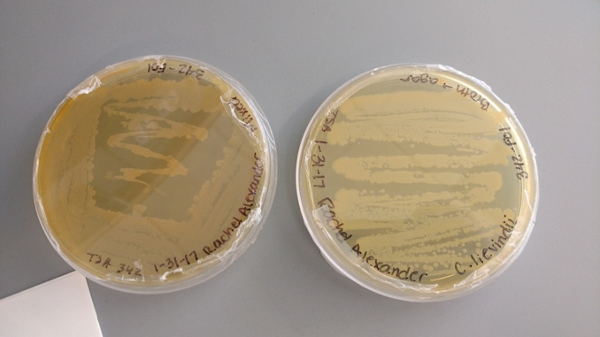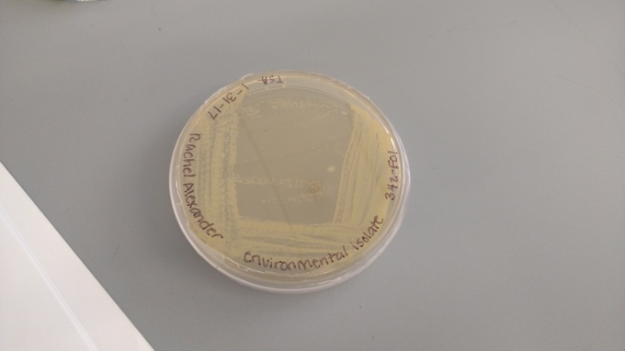
Figure 1. Original sample streaks after one week of growth. Figure 2. Isolate streak on 1/13/17

The first figure shows the original sample streaks that were allowed to grow for one week before the sample was re-streaked to further isolate the bacterial strain. Figure 2 showed the further isolation of the strain. The streak is noticeably less growth as the bacteria became more isolated. Once the sample was more isolated a gram stain was preformed and the results showed that the bacteria sample was gram positive, shown in figure 3. This gram stain was preformed twice in order to confirm the result because the first slide produced resulted in an inconclusive result.
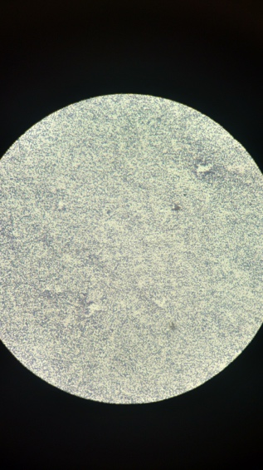

Figure 3. Gram Stain of Isolate View at 100X
After the gram stain was preformed and the bacterial was isolated further
Assembly | Contigs
# contigs (> 0bp) | 759
# contigs (>1000 bp) | 553
Total length (> 0bp) | 2335524
Total length (>1000 bp) | 2204160
# contigs | 707
Largest contigs | 27432
Total length | 2312335
Table 1. Base Space Analysis Data from
Feature Type | Number Found
tRNAs | 58
rRNAs | 0
CRISPRs | 0
CDS | 2004
Assembly Length | 2335096
# contigs | 756
Contig N50 | 5101
Table 2. Base Space Analysis Data from Prokka Genome Annotation
Discussion
Based on all the results from the testing I have performed on my bacterial strain isolated from a dog’s mouse, I have concluded that this bacterial strain is in fact Staphylococcus Epidermis. Staphylococcus Epidermis is a gram positive, opportunistic pathogen that can be found on most humans and animals that have skin and mucosal regions of the body. Although this strain is not as aggressive as its cousin Staphylococcus Aureus, it still ranks very high on the list of bacterium that cause nosocomial infections, because it is the most common source of bacteria found on indwelling medical devices. S. Epidermis does not often lead to life threatening infections however the frequency and difficulty of health care professionals has cause a lot of problem for our health care system. (Otto 2009).
S. Epidermis, being gram positive means that it can survive in harsher environments because of the thicker outer cell wall it possess. Being found in a dog’s mouth, a relatively harsh environment for cells, these cells would have to combat with the dog’s saliva which is widely known for being very good at breaking things down. In order survive in this environment they would have to possess a thick cell wall for protection.
My strain of S. Epidermis did not present any resistance to a select few antibiotics that were tested. This is the predicted outcome because the dog was very young, less than 2 years old, and has not been exposed to very many viruses and has not needed any medication. If no medication has been presented into the system, the S. Epidermis would not have any need to mutate and develop any resistance.
Further testing and research could one day provide a conclusion as to why S. Epidermis is the only strain of Staphylococcus that is not an aggressive pathogen. However, there are a few tips provided by researchers that could help prevent S. Epidermis from becoming harmful. These include, “better hygienic procedures in the medical profession, prophylactic use of antibiotics during surgical procedures, and covering and incorporating of implanted materials by antibiotics and other agents with antibacterial activities” (Vuong, Otto 2002). With small changes in certain habits S. Epidermis can remain cohabitation on our skin without causing us, or other organism any harm in the future.

Literature Cited

O’Gara, Dr. J.P., Humphreys. H., 01 July 2001. Staphylococcus epidermidis biofilms:
importance and implications. Journal of Medical Microbiology. 50:582-587
Otto , M. (2009). Staphylococcus epidermidis — the 'accidental' pathogen. Nature Reviews
Microbiology , 7, 555-567. Retrieved April 09, 2017, from http://www.nature.com/nrmicro/journal/v7/n8/full/nrmicro2182.html
Vuong, C., & Otto, M. (2002). Staphylococcus epidermidis infections. Microbes and
Infection,4(4), 481-489. doi:10.1016/s1286-4579(02)01563-0

