Isolation and Characterization of Micrococcus Luteus From an Apartment Door Handle
Introduction
The pervasive nature of microbes is a fact of life; and that knowledge leads to a concern for the transmission of potentially pathogenic microbes on surfaces humans will inevitably contact. Research done in the domestic environment has looked at perceived high risk areas for contamination including: bathing areas, toilets and kitchens; and the probability of transmission of pathogens increases inside an infected domicile (Kagan, Aiello, Larson 2003). Similarly, the presence of human microflora is also pervasive as there can be as many as one trillion present on the skin, many working to create a protective barrier from pathogens in various ways (Nakamizo, et al. 2014). Commonly a predominant bacterium on human skin, Micrococcus luteus, was the bacteria I isolated and then identified during the course of this research. M. luteus was first discovered by Sir Alexander Fleming and is a copiotrophic obligate aerobe cocci that has been utilized for research since its discovery for reasons including its high GC content and its dormancy capability without the formation of spores (Young, et al. 2009).
The objective of this experiment was to sample the entryway door handle of a domicile in order to isolate, characterize, and identify bacteria present on that surface. A sample from the door handle was inoculated and grown in order to select a random single colony for plate streaking until isolation could be achieved. That colony was then isolated and identified via genetic sequencing and physiological testing. Due to the state of good health of the tenants of the domicile, it was hypothesized that the most prevalent and therefore most readily isolated bacteria found on the surface of the door handle would be commensal and commonly found on the human skin.
Methods
The original sample for this isolate I took from the interior door handle of an apartment using a sterile swab, first moistening it with sterile water to more readily retrieve any microbes present. I streaked the swab onto a TSA plate and incubated it in a dark closet for two days at room temperature (approximately 24° Celsius) in the apartment. From this plate, I selected a single colony and I used quadrant streaking to obtain a pure bacterial isolate culture as directed in Lab 2 Handout. I incubated each streak plate at 37°C in the lab incubator until colonies formed, and then refrigerated (approximately -20°C) the plate to stabilize the bacteria and slow growth until the next streak was performed. I continued this process between each successive test to consistently keep either a TSA plate or slant of isolate of fresh bacteria available for testing. Once four quadrant streaks were performed, I Gram stained the bacteria per the protocol in Lab 4 Handout in order to ascertain the if the cells were Gram –positive or Gram-negative, giving an indication of the cell wall structure. The test also allowed for a microscopic check for uniformity of cell type that could also attest to the purity of the isolate culture.
I performed the DNA extraction per the protocols listed in Lab 5 Handout using the PowerSoil DNA Isolation Kit. This included lysing the cells and isolating the DNA from inhibitors and enzymes that would degrade the available DNA. I then purified the DNA per the instructions in Lab 5 Handout using the same Isolation kit in order to submit the sample to the UAF DNA Core Lab technician. Whole genome sequencing was done using Illumina MiSeq technology. Once completed I utilized Illumina’s BaseSpace online software applications (SPAdes Genomic Assembler, Kraken Metagenomics, and Prokka Genome Annotation) to analyze the sequencing runs and populate matches for identifying the bacteria against the genomic database’s archives.
I preformed physiological testing on the bacterial isolate utilizing multiple tests (Lab 6 Handout). I conducted a fluid thioglycollate test, inoculating it at room temperature for 24 hours, in order to determine the oxygen class of the bacteria, an oxidase test to detect the presence of cytochrome oxidase c, which can be used to to determine whether the isolate is enteric or pseudomonad bacteria. Further physiological tests included: a Catalase test for the ability of the bacteria to release O2 in the presence of reactive oxygen species, and an API 20E strip test which tested for 21 different traits. Once the API 20E test was inoculated for 24 hours in a 37° incubator, I returned and performed secondary tests as directed by the Lab 6 Handout protocols in order to test for the presence of tryptophane deaminase, indole production, acetoin production, and Nitrate reduction in the bacteria.
Results
Gram stain results of the bacterial isolate showed gram-negative bacteria under 100x magnification (Figure 1). These bacteria were cocci in morphology approximately 1.5µm in diameter. I observed cells growing in tight clusters, though a few possible tetrads and pairs were also observable, with no obvious signs of biofilm or slime. The fluid thioglycollate test showed the isolate to be a strict aerobe. The catalase enzyme test was positive for the presence of that enzyme in the bacteria. Testing for cytochrome c oxidase had negative results indicating a lack of the oxidase enzyme in the isolate.
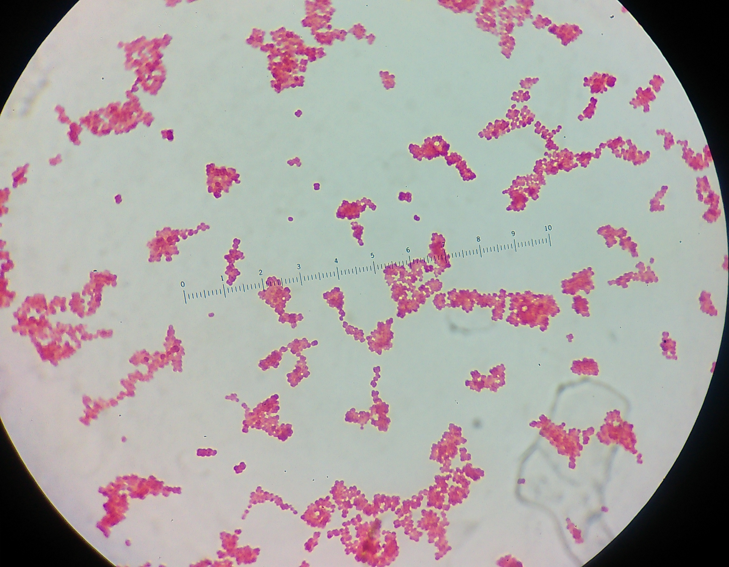
Figure 1. Photo of gram stain results of M. Luteus isolate.
After 24 hours, API 20E test strip inoculated with the isolate showed negative results for each test except for the presence of gelatinase, indicating the isolate is able to hydrolyse gelatin. Subsequent tests on the TDA, IND, and VP wells yielded negative results. When I performed supplementary Nitrate reduction tests on the Glucose well, there was no reduction of Nitrate neither to NO2 nor to N2 gas. The resulting API 20E code was 00020000, which when checked against the APIweb database identified an Arthrobacter species of bacteria.
The isolate DNA sequence data was analyzed by BaseSpace utilizing the SPAdes Genomic Assembler, Kraken Metagenomics, and Prokka Genome Annotation applications. The cloud software assigned the bacterial isolate as Micrococcus luteus, at the species level with a confidence of 79.63%. A total of 19% of genomic reads were marked “unclassified.” Sequencing identified 52 tRNAs in the sample, with no rRNAs, CRISPRS, or coding genes (CDs) present.
Antibiotic resistance testing showed susceptibility to all but two of the antibiotic discs viewed. After 48 hours, the isolate showed susceptibility toward the following: Cefoperazone, Amikacin, Gentamicin, Tobramycin, Vancomycin, and Cefazolin. For the oxacillin and trimethoprim discs the isolate grew up to and under, showing complete resistance to those antibiotics as per the antibiotic zone diameter interpretation table featured in Lab Handout 9 (Figure 2).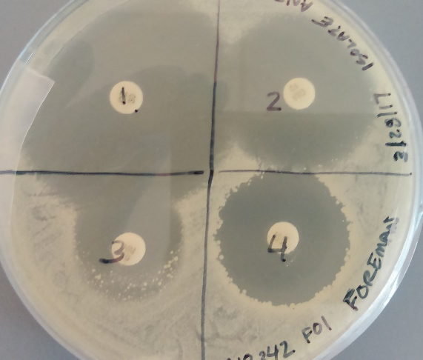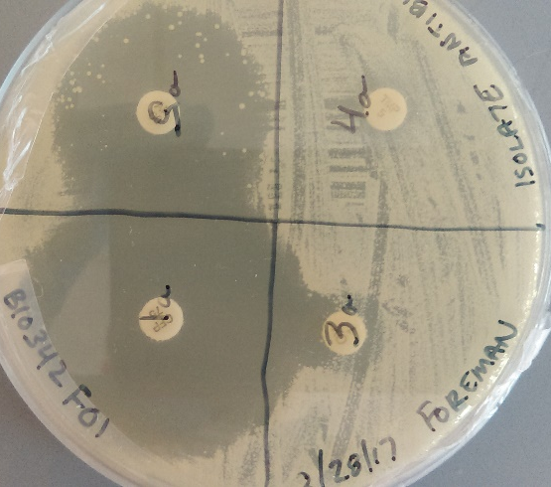
Figure 2. Antibiotic Resistance plates.
Discussion
The presence of Micrococcus luteus on my apartment door handle is consistent with the transferability of the bacteria from its common human habitat, the skin (Kloos and Musslewhite 1975). M. luteus variants are oligotrophic to copiotrophic and have the ability to achieve dormancy in extreme conditions without sporulation (Kaprelyants and Kell 1993). Thus, isolating this bacteria from a door handle, with frequent contact to a typical habitat where M. luteus is found, is predictable. Several of the physiological tests gave inconsistent results with the BaseSpace and GenBank Blast analysis identifying the isolate as M. luteus, particularly the gram stain.
M. luteus is typically identified as a gram-positive or gram-variable bacteria. Early on in lab, I stained the isolate and it was gram-negative. This contradictory result is most likely due to some procedural error or possibly the age of that particular colony stained. Even if the strain of M. luteus that I isolated was gram-variable, there would have been some evidence of gram-positive cocci in the slide. Though predominantly observed in clusters in the stained isolate, there are observable tetrads which are commonly found in Micrococcus species (Greenblatt et. al. 2003).
The API 20E physiological test identified Arthrobacter sp. As the possible species. While this species is in the same taxonomic family (Micrococcaceae) as M. luteus, morphologically, there were no rods present in my isolate, and Arthrobacter has a rod and cocci stage in development, so some rods would likely have been present (Young et al., 2010). API Staph test gave all negative results, helping to exclude the possibility of the isolate actually being previously identified as a Staphylococcus species.
My isolate of M. luteus showed antibiotic resistance to oxacillin and trimethoprim. Had time and resources permitted, the isolate would be tested for susceptibility to bacitracin. Resistance to oxacillin has been demonstrated in M. luteus in the literature (Greenblatt et.al. 2003).
Sequencing of the isolate did not return with any 16S rRNA present, limiting the comparability of the isolate to existing genomic data in Ilumina’s BaseSpace. The SPAdes Genome Assembler report produced a GC percent of 72.84%, which is consistent with established genomic GC percentage of greater than 70% (Hanafy et. al. 2016). The PROKKA analysis found many markers for specific genes in the isolate. The first of note is a pH-sensitive adenylate cyclase, which is possibly induced in hypoxic periods to aid in dormancy. Second, a putative oxidoreductase gene was identified which aids in general oxidation for cell processes. Third, a peptidoglycan biosynthesis protein coding gene which would be important for the production of peptidoglycan for bacterial cell walls.
Having performed dozens of tests in the pursuit of isolating and identifying one pure culture my hypothesis of finding a non-pathogenic bacterium was borne out. The presence of M. Luteus on my apartment door handle is no real surprise when the number of human skin microflora are nearly a trillion on each person. The genomic analysis was relied upon heavily for the identification of this isolate due to what is most likely procedural/human error in the performance of physiological testing. The research here would have benefited from further gram staining and completing a secondary API 20e test strip for more accurate results.
Literature Cited
Greenblatt, C. L., Baum, J., Klein, B. Y., Nachshon, S., Koltunov, V., & Cano, R. J. (2004). Micrococcus luteus - Survival in amber. Microbial Ecology, 48(1), 120–127. https://doi.org/10.1007/s00248-003-2016-5
Kagan, L. J. (2002). The Role of the Home Environment in the Transmission of Infectious Diseases. Journal of Community Health, 27(4), 247–267. Retrieved from http://resolver.scholarsportal.info/resolve/00945145/v27i0004/247_trotheittoid.xml
Kaprelyants, A. S., & Kell, D. B. (1993). Dormancy in Stationary-Phase Cultures of Micrococcus luteus : Flow Cytometric Analysis of Starvation and Resuscitation Dormancy in Stationary-Phase Cultures of Micrococcus luteus : Flow Cytometric Analysis of Starvation and Resuscitation. Applied and Environmental Microbiology, 59(10), 3187–3196.
Kloos, W. E., & Musselwhite, M. S. (1975). Distribution and persisitence of _Staphylococcus_ and _Micrococuss_ species and other aerobic bacteria on human skin. American Society of Microbiology, 30_ _(3), 381–395.
Miller, N. T., Fuller, D., Couger, M. B., Bagazinski, M., Boyne, P., Devor, R. C., … Youssef, N. (2016). Draft genome sequence of Pseudomonas moraviensis strain Devor implicates metabolic versatility and bioremediation potential. Genomics Data, 9, 154–159. https://doi.org/10.1016/j.gdata.2016.08.004
Nakamizo, S., Egawa, G., Honda, T., Nakajima, S., Belkaid, Y., & Kabashima, K. (2015). Commensal bacteria and cutaneous immunity. Seminars in Immunopathology, 37(1), 73–80. https://doi.org/10.1007/s00281-014-0452-6
Young, M., Artsatbanov, V., Beller, H. R., Chandra, G., Chater, K. F., Dover, L. G., … Greenblatt, C. L. (2010). Genome sequence of the fleming strain of Micrococcus luteus, a simple free-living actinobacterium. Journal of Bacteriology, 192(3), 841–860. https://doi.org/10.1128/JB.01254-09

