Brianna Kriesel
BIOL 342 – Lab 03
Lab Paper

Identification and Characterization of Bacteria from Cheek

Introduction
Microbes are everywhere. They are all around us at almost all times in our life, whether it’s in the air we breathe, the water we drink, or the surfaces we touch. They cover our skin and fill our bodies. They are so diverse and abundant and some can live in even the most extreme environments. Microbes are essential in our everyday life.
According to Ji-Hoi Moon, the human microbiome itself contains such a wide variety of microorganisms that it exceeds the number of human somatic and germ cells by at least a whole order of magnitude (Moon and Lee 2016). These microbes can either work to keep the body healthy or they can work against it by causing infections or diseases. One of the best and easiest places to find a wide diversity of microbes in the human body is the mouth. It is warm, humid, and has a relatively neutral pH, making it an ideal place for microbes to thrive. There are also many different structures and pockets throughout the mouth where different niches can form, leading to a greater diversity of bacteria (Dewhirst 2010).
The objectives of this study were to isolate, characterize, and identify a bacterium from the inside of a human’s mouth. In order to study this bacterium, I collected a sample from the inside of my roommate’s cheek and grew the culture on a Tryptic Soy agar plate. I then isolated the bacterium into a pure culture over several weeks with the Streak Plate Method. Using this pure culture, I performed a variety of physiological tests and DNA sequencing.
Based on the fact that the cheek is so close to the outside environment, I believe that my bacterium will be an aerobe or a facultative anaerobe. After performing multiple tests on my isolate, I determined that it is Corynebacterium frankenforstense

Methods
Sample Collection
To begin this experiment, I used a sterile cotton swab to collect a bacteria sample from the inside of my roommate’s cheek and then I streaked this sample onto a Tryptic Soy Agar (TSA) plate. I sealed the plate and stored it at room temperature for one week. Next, I began the process of obtaining a pure culture by selecting a colony that had grown and using the Streak Plate Method (Lab 2 Handout). I incubated my new plate at 37°C for two days and then repeated this process three more times before obtaining a pure culture (Figure 1).
Figure 1: Isolated Culture
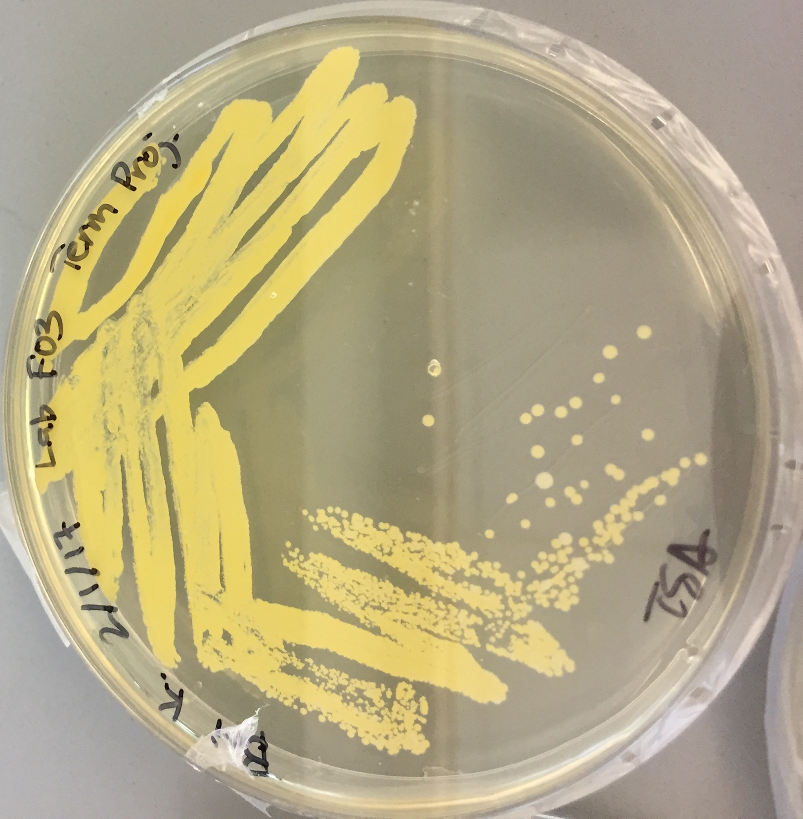

Identification and Characterization
After isolating the culture, I performed a gram stain on my bacteria (Lab 4 Handout) to determine if my isolate was Gram-negative or Gram-positive. Next, I conducted multiple physiological testing on the bacteria (Lab 6 Handout). I use a fluid thioglycollate test to reveal the oxygen class (aerobic, facultative, or anaerobic) of my isolate. After incubating at 37°C for three days, I was able to see these results. Next, I performed a catalase test in order to test whether the enzyme catalase was present in my bacteria. After that, I did an oxidase test to determine if cytochrome c oxidase was present. Finally, I performed a series of tests using an APIE test strip. I then incubated the test strip at 37°C for five days.

Genome Sequencing
After completing the physiological testing for my isolate, I extracted DNA from my isolate using the MoBio Powersoil DNA Isolation Kit (Lab 5 Handout) and then my sample was sent to the DNA Core Lab for genome sequencing. Two weeks later, I used bioinformatics via BaseSpace to analyze my results. Within BaseSpace, I used the applications SPAdes Genome Assembler, Kraken Metagenomics, and Prokka to assemble the genome, assign taxonomy, and annotate functional genes for my isolate.

Antibiotic Testing
After genome sequencing, I tested my isolate for antibiotic resistance. I used a disk diffusion test (Kirby-Bauer Method) to determine the susceptibility to eight different antibiotics to include: Piperacillin, Oxacillin, Tobramycin, Erythromycin, Cefazolin, Cefoperazone, Cefotaxime, and Amikacin. To do this, I inoculated the plate with the bacteria and placed disks infused with the above mentioned antibiotics into differet zones. After a few days, I then measured the zone of inhibition around each disk in order to indicate the order of resistance or susceptibility to each one.

Results
The summary of results for the physiological tests performed in this study can be seen in Table 1 below. The results of my Gram stain revealed that my bacteria is Gram-positive and can be seen is Figure 1 below. The fluid thioglycollate test that I performed helped me determine that my bacteria is strictly aerobic because it only grew within the surface layer of the tube, where oxygen is present. The catalase test resulted in bubbles forming after I had added hydrogen peroxide. This means that my bacterium is catalase-positive and that the enzyme catalase is present. The oxidase test came back as negative because no color appeared on the strip, meaning my bacteria does not have cytochrome c oxidase. The last physiological tests performed, API 20E test strip, only revealed one positive result in the URE tube. This means that Urease is present. All other tests on the strip were negative. As a result of this, I then performed an API test strip meant for Gram-positive bacteria, the API 20Strep test. This revealed the presence of Lactose and Pyruvate in my bacterium.
The BaseSpace program yielded no results as it yielded 0 hits for my bacterium. Because of this, my genome sequencing was interpreted using bioinformatics through the BLAST program instead. The nucleotide sequence of my bacteria revealed that my isolate matched with a query coverage of 7% with Schistocephalus solidus, 13% with Ralstonia solanacearum, and 50% with Corynebacterium frankenforstense.
The antibiotic testing revealed that my isolate is very susceptible to all but one of the antibiotics tested, Erythromycin. Every other antibiotic resulted in a zone diameter of 30mm or more. In the presence of Erythromycin, the bacterium had no susceptibility and a zone diameter of 0mm.
Table 1: Summary of Physiological Test Results
Test | Results
Gram Stain | Positive
Fluid Thyglycollate | Aerobic
Catalase | Positive
Oxidase | Negative
API E test strip | URE positive

Figure 2: Gram stain results
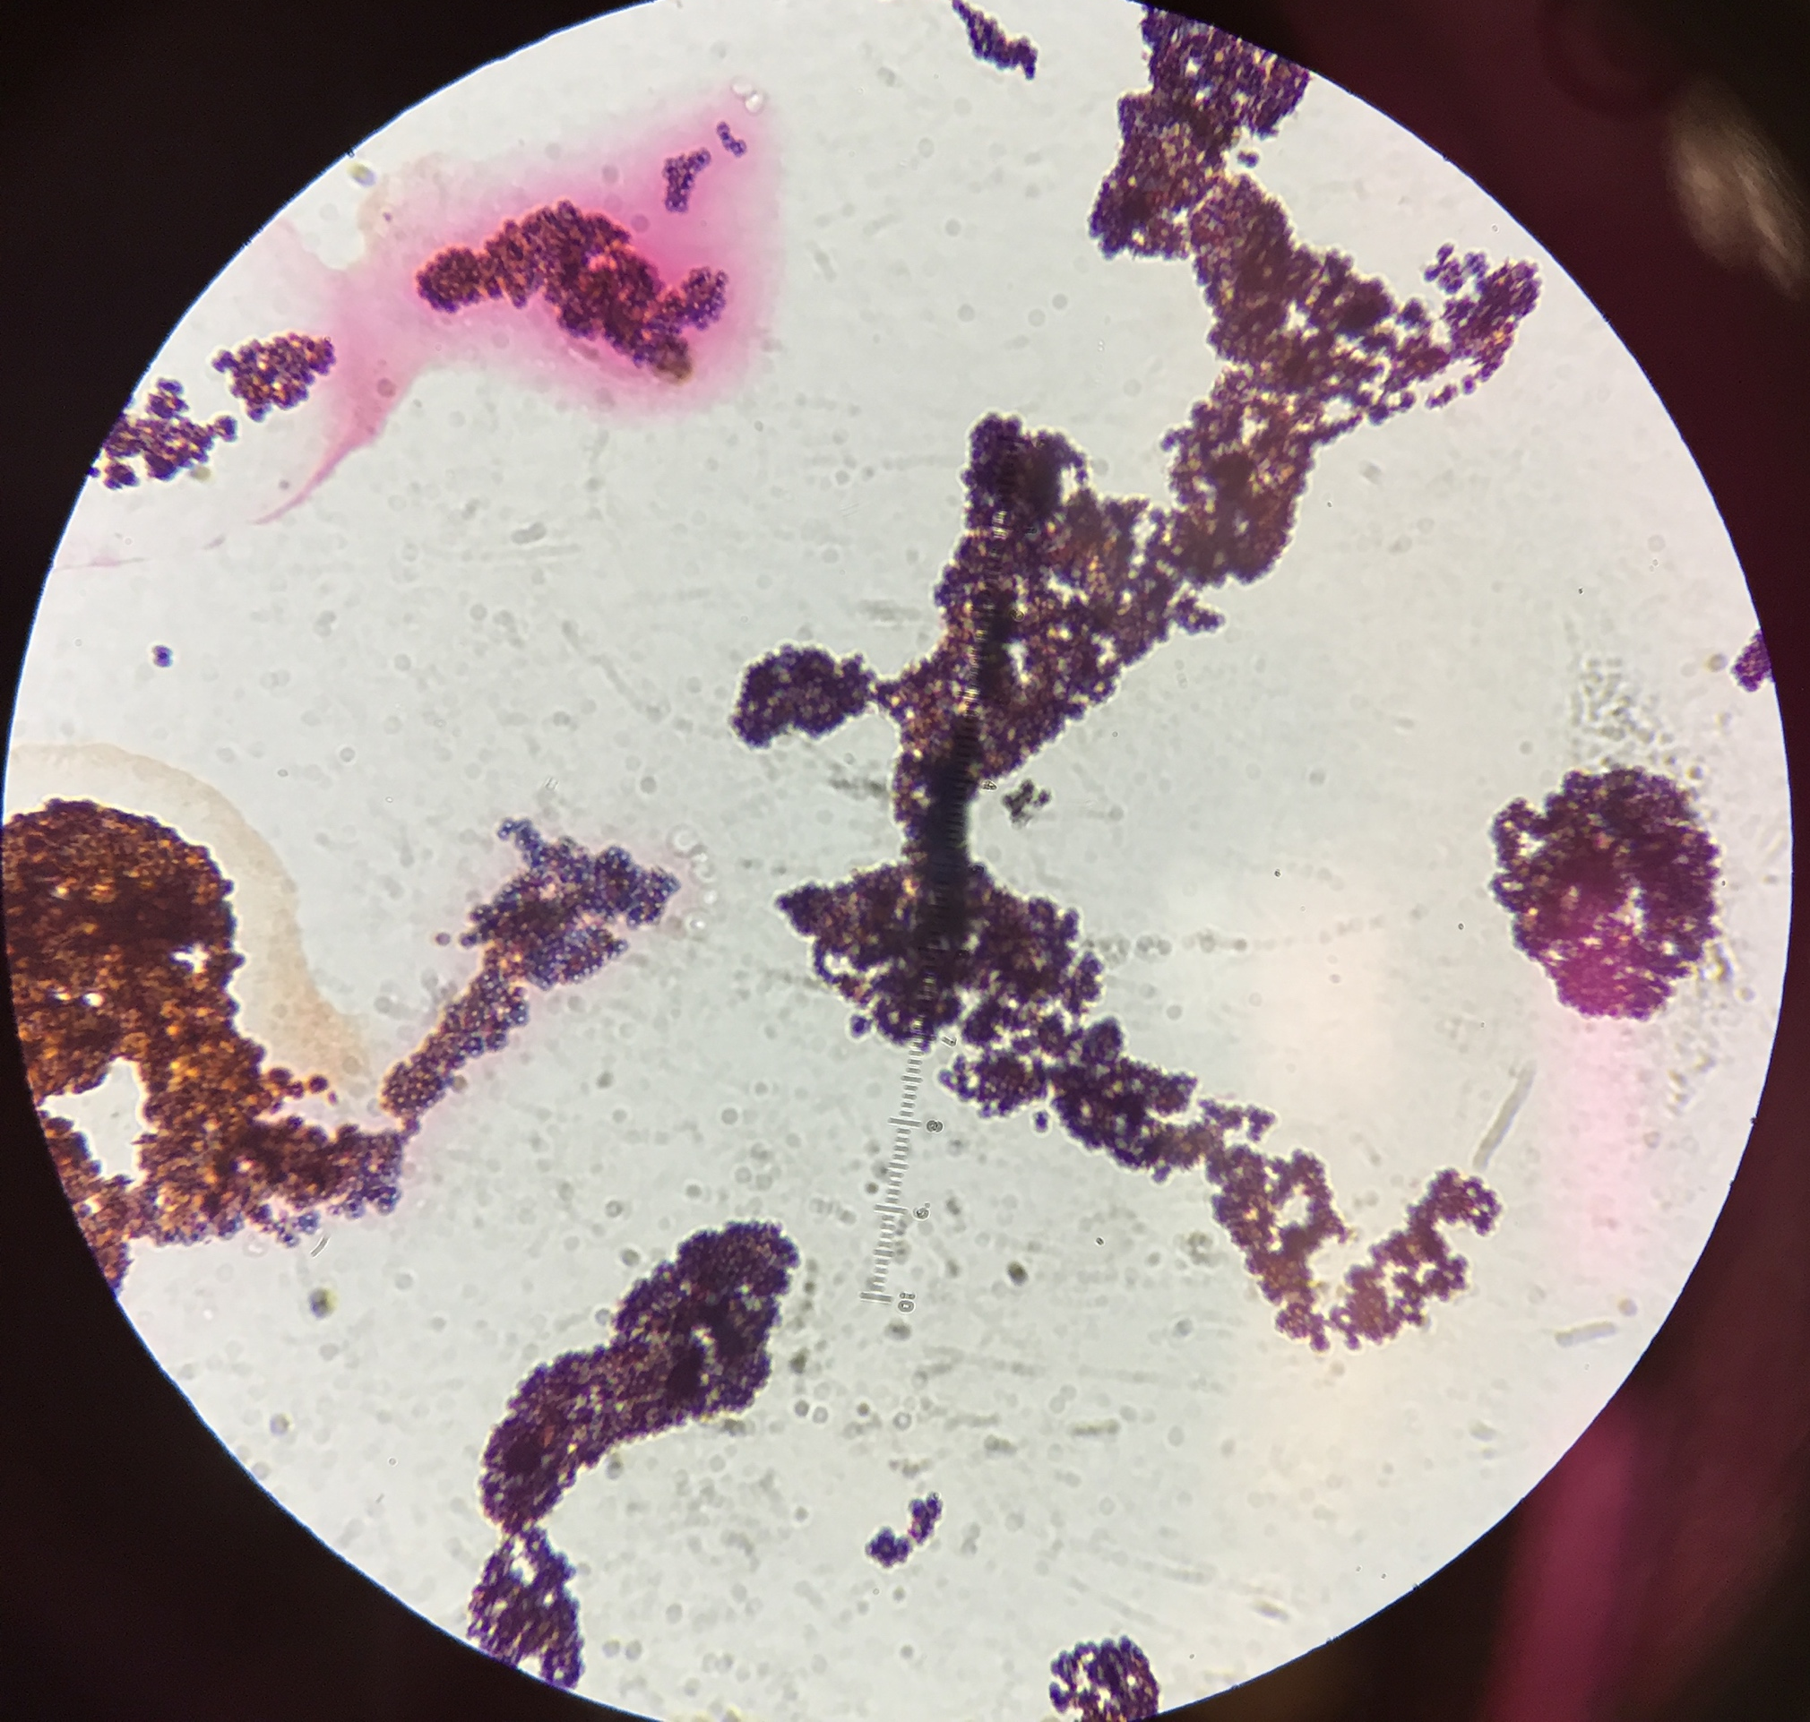

Discussion
The physiological test results that I received were consistent with Corynebacterium frankenforstense (Wiertz, 2013). As stated in the literature, Corynebacterium frankenforstense is a Gram-positive, aerobic bacterium that is typically found in cow milk. This would make sense if I had a milk-based product prior to swabbing the inside of my cheek.
There is a severe lack of taxonomic information about the dairy associated strains, so many things are unknown about my specific strain. Corynebacterium strains are often difficult to identify as there is a continuous increase in species number for this genus. The genus Corynebacterium was one of the earliest discovered bacterial genera and it was thought to be the causative organism for diphtheria. Many species of this genus are associated with mastitis in mammals, especially cows. All isolates of Corynebacterium found in dairy farms were found to be Gram-positive, catalase-positive, oxidase-negative, rod-shaped, and non-motile. These characteristics matched up perfectly with my results of the physiological testing of my isolate. These strains also grow best at 42°C and my isolate was growing at 32°C.
This bacterium was found to be extremely susceptible to most of the antibiotics that were tested. The only thing it was resistant to was oxacillin. This is consistent with the literature because many Corynebactium strains are found to be susceptible to most common antibiotics.
My hypothesis was supported by my research because my isolate was aerobic and commonly found in milk, which can therefore be found in mouths. However, since my genomic results weren’t incredibly reliable, my isolate could be something different. If I were to do more research on this isolate, I would perform another API test, such as the API Coryne system because none of my API results were very informative. I would also like to run the 16S rRna gene sequencing, as my results were not available to me through BaseSpace.
Literature Cited

Dewhirst, F.E., T. Chen, J. Izard, B.J. Paster, A.R. Tanner, W.H. Yu, A. Lakshmanan, and W.G. Wade. 2010. The human oral microbiome. Journal of Bacteriology 192:5002-5017.

Moon, J.H., and J.H. Lee. 2016. Probing the diversity of healthy oral microbiome with bioinformatics approaches. BMB Reports 49:662-670.

Wiertz R., S.C. Schulz, U. Müller, P. Kämpfer, and A. Lipski. 2013. Corynebacterium frankenforstense sp. nov. and Corynebacterium lactis sp. nov., isolated from raw cow milk. International Journal of Systematic Evolutionary Microbiology 63: 4495-4501.

