BIOL F342
Albert Espejo
4/28/2017
Ms. Mary Beth Leigh

Identification and characterization of Corynebacterium simulans isolated from a gaming console
Introduction:

Everyone knows the clichéd phrase “Microbes are everywhere”, yet it cannot be stressed enough how diverse they are and how vital they are to life. Microbes are literally found anywhere and they are ubiquitous (Madigan). With that in mind, the goal of this project is to identify and characterize a species of bacteria residing in a household object. There are numerous household objects that are teeming with microbes and areas in your house such as the kitchen and the bathroom. Along with different kinds of objects that could be potentially housing microbes, the most common items with most germs/bacteria are kitchen sponges and rags, cutting boards, kitchen surfaces, sink drains, doorknobs, and toothbrushes (Joseph Mercola, 2003). These items have different kinds of microbes and if not careful it could house a pathogenic bacterium.
There are billions of bacteria that scientists haven’t discovered yet, but the ones that were discovered were astoundingly diverse, especially their metabolism (Madigan). The goal of this project is to find a certain bacteria that normally resides on household objects. The most common bacteria found at home are Methicillin-resistant Staphylococcus aureus (MRSA), E. coli, Norovirus, and Clostridium difficile (Beware of common household germs, 2014). With this in mind, I decided to utilize a gaming console, PlayStation 4 (PS4) to be exact, as the household object, which provided the bacterial source of this whole project. I hypothesized that the specific bacterial species that I could find on the gaming console should be related to the bacterial species that were mentioned earlier. I, also, predicted that my hypothesis would be supported on this project.

Methods

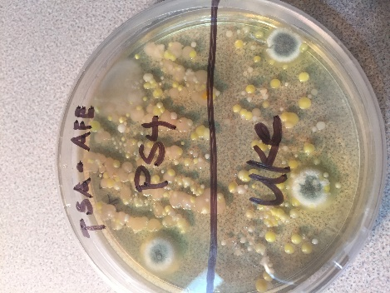
To start the project, I used a cotton swab, dipped in sterile water, to get a bacterial sample from the PS4. I streaked the swab in a zigzag fashion to two different media plates: Tryptic Soy Agar (TSA) and Sabouraud’s Agar (SA) plates. I ensured that I swabbed aseptically and that I did not cause contamination for each plate. This was done to observe how microbes from same sources react to different media, which have different growth factors or chemical ingredients. For instance, TSAs are more preferred for bacteria, whereas SAs are preferred for fungi. After waiting for 2-3 days, I noticed bacterial growth on the TSA plate (Figure 1).
Figure 1: Bacterial growth from TSA plate after 2-3 days.
As we learned aseptic techniques, which was introduced in Lab 2, we started inoculating our microbial samples to obtain a pure culture. I inoculated my bacteria to a new TSA plate, but this time I used quadrant streaking instead of a zigzag formation in order to obtain an isolated bacterial colony, which are vital to obtain pure cultures. Through the open-labs, I transferred my microbes to new TSA plates aseptically to obtain a pure culture. TSA plates were incubated at about 37 degrees Celsius.
To identify and characterize our bacterial isolates, phenotypic and genotypic tests were coordinated. As for the physiological tests, Gram staining test was conducted to identify if my isolate was Gram-positive or Gram-negative. To identify the oxygen class, fluid thioglycollate test was conducted. Oxidase test was performed to determine if the bacterial isolate can produce cytochrome c oxidase, which is an enzyme. In order to identify if the bacterial isolate can catalyze the release of Oxygen from Hydrogen Peroxide, we ran the catalase test. Lastly, we carried out Analytical Profile Index test or API 20E strip test, which had at least 20 miniature tests in one test strip. All of the protocol and information about the physiological tests are present in Lab 6.
Once a pure culture was obtained or attempted, it’s important to run genotypic analyses as well. Genomic sequencing and DNA extractions are vital to identify and characterize an unknown isolate. With that said, taxonomical classifications will be reachable if genotypic tests were conducted. In Lab 5, we conducted DNA extraction. First, we basically broke the cells open to release their DNA by Cell lysing. Second, we removed inhibitors and proteins to purify the DNA. And finally, we obtained a pure solution of DNA, which is usually in a buffer solution. After extracting DNA, we gave our samples to our T.A. to be given to a DNA Core Lab technician, who performed our sequence analysis. Finally, I tested my isolate’s antimicrobial properties to test their susceptibilities and resistances. I decided to test for Erythromycin, Oxacillin, Tetracycline, Vancomycin, Gentamycin, Amikacin, and Cefazolin.

Results

Two types of tests were conducted in this project. One is physiological test and the other was genotypic test. Starting with the physiological tests, the Gram-stain lab activity concluded that my isolate was a mixed culture to begin with. Regardless of the effort of creating a pure culture through quadrant streaking, my isolate turned out to be mixed and potentially contaminated by other microbes. Under the microscope, it showed both Gram-positive purple color and Gram-negative pink/red coloration. The morphology of my isolate showed various shapes such as coccus, rods, tetrads, and mostly compacted bacteria (Figure 2).

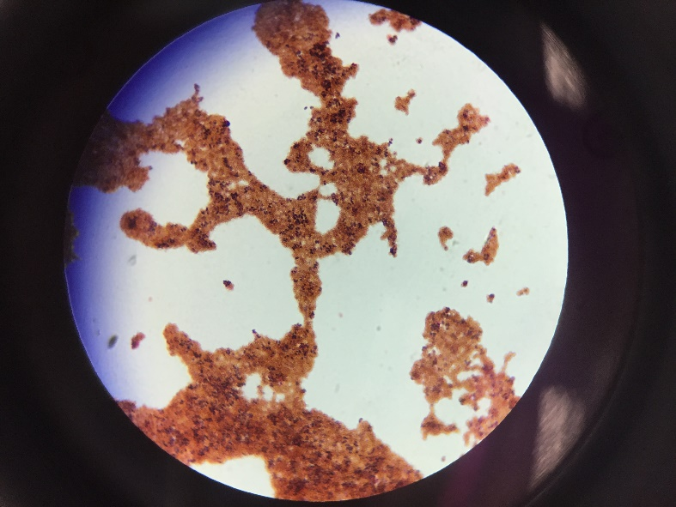
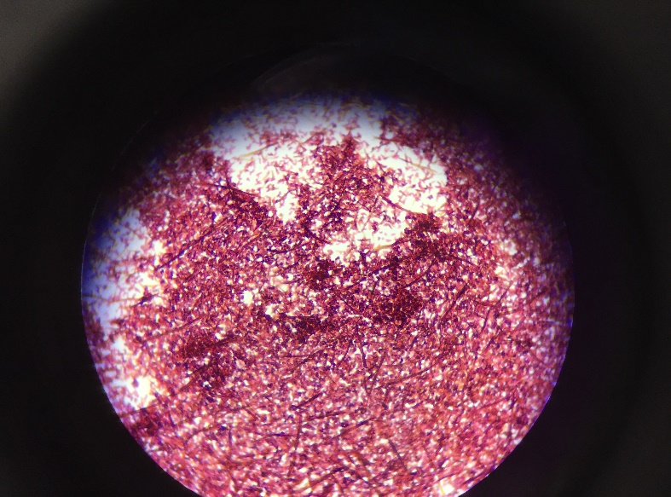
Figure 2b. This picture shows my isolate as a mixed culture. This was my 2nd attempt for Gram-staining my isolate.
Figure 2a. This picture shows that my isolate has mixed culture. 1st trial of Gram-staining.

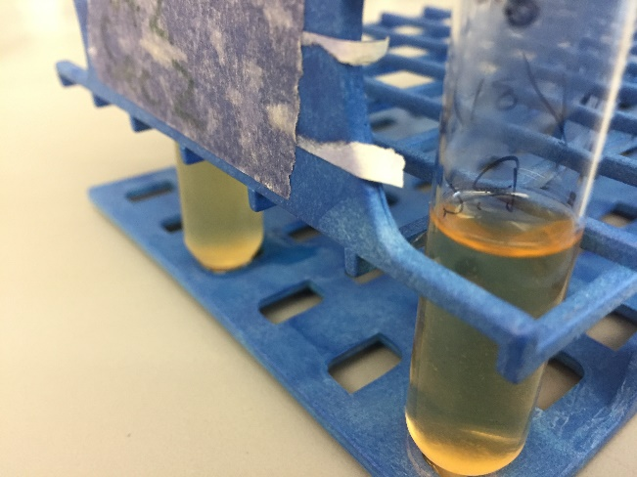
Oxidase test was conducted to my isolate to test if it contains an enzyme known as cytochrome c oxidase, which helps on distinguishing if a bacteria is a pseudomonad or an enteric species bacteria. My isolate turned out to be positive on the oxidase test, which means that it could be similar or related to a pseudomonad species. As for the catalase test, once I introduced my isolate to Hydrogen Peroxide it started bubbling up, which indicates that my isolate has the ability to use Oxygen as its electron acceptor. For the fluid thioglycollate test result, my isolate showed an unusual route which is inconclusive. The result turned out that my isolate was unreactive to the fluid thioglycollate test. (Figure 3). As you can see on the figure above, the test tube on the right contains my fluid thioglycollate test. It clearly shows that it is inconclusive. Because of this result, I decided to attempt the test again. For the second time, I finally were able to get an answer. My isolate turned out to be an obligate aerobe, which is an oxygen class of microbes where Oxygen is the primary electron acceptor and that it might not have fermentation ability or other metabolic flexibility.
Figure 3: Indicates my Fluid thioglycollate result, which was inconclusive. My isolate tube is the one on the right side.
The final physiological test that I conducted was the API20E strip test. After conducting and waiting for approximately 1-2 days, my result finally came. My result stated that my isolate didn’t react to this test, thus I reached an inconclusive result once again. Feeling unsatisfied with this outcome, I decided to conduct a similar test, which was Strep test. Originally, the API20E is focused more on Gram-negative bacteria, this could mean that my isolate could be a Gram-positive one. The Strep test was similar to API20E, it focuses on Gram-negatives but resulted positive on catalase tests. The result came out inconclusive.

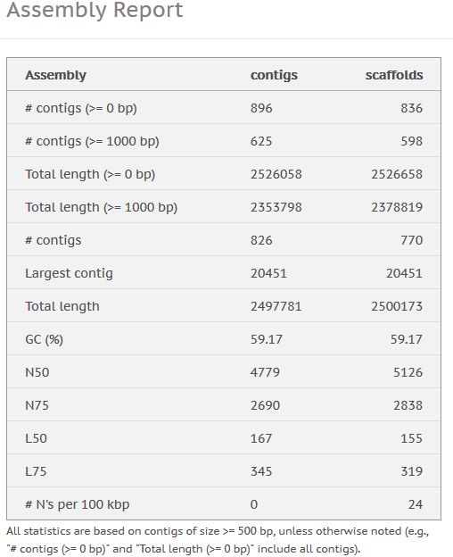
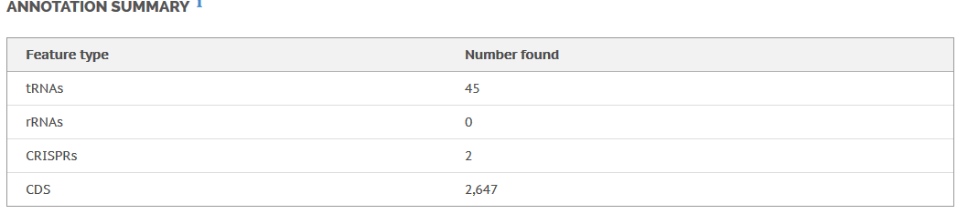
As for the genotypic tests, I used Based Space account or Illumina and also utilized BLAST. As for the Base Space result, it gave me several data that were pretty interesting. Prokka Genome stated that my isolate has a total length of 2,524,958 and 888 number of contigs. It also showed other interesting data (Figure 4)
Figure 5: Indicates information/data SPAdes provided.
Figure 4: This Figure shows the data Prokka Genome discovered on my isolate.
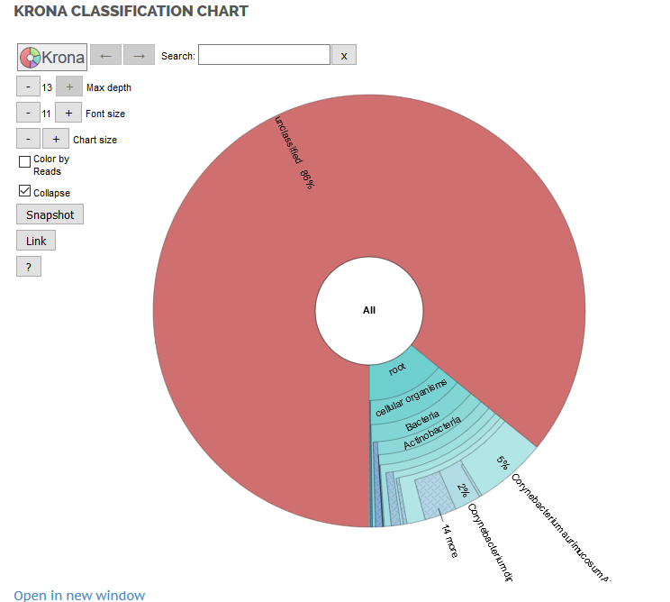
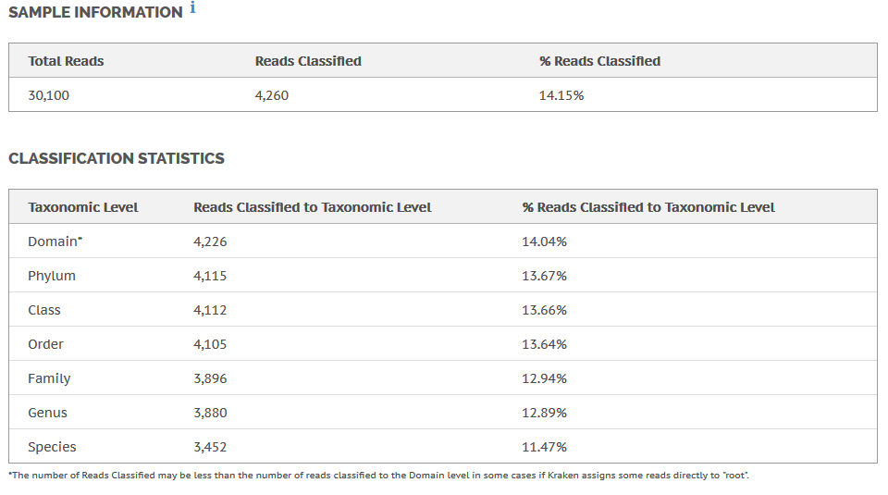
Another data from Base Space, SPAdes Genome also supplied genotypic data of my isolate. SPAdes provided me data about the number of contigs, total length, largest contig and etc. of my isolate (Figure 5). Lastly, one of the most interesting information base space provided was from the Kraken Metagenomics. It identified what my isolate could be as a species. Basically, it provided taxonomic data, which was vital information to reach my goal for this project. Kraken Metagenomics indicates information regarding the Taxonomic data of my species, the total reads, and the confidence level of the readings (Figure 6).
Figure 6: Shows the number of reads and its confidence percentage. More importantly, shows a potential taxonomic data of my isolate.

Based on the Kraken Metagenomics, my isolate is approximately 86-87% unidentified, but has the next decent percentage of 8% for Corynebacterium aurimucausum. This simply stated that my isolate was unknown for Base Space, but stated that it’s potentially C. aurimucausum. With this data in hand, I decided to use BLAST and double-check if my isolate could potentially be C. aurimucausum. BLAST showed a marvelous job of identifying my isolate and provided me with 98% confidence that my isolate could be Corynebacterium simulans (Figure 7).

Discussion
Figure 7: This figure shows BLAST’s data regarding identification of my isolate, Corynebacterium simulans.

After taking all the physiological data and genotypic data from the previous labs, I think that I’m ready to discuss if my isolate is really what the results was, if it agrees to the literature, and if my prediction was not supported by the facts. Unfortunately, based on a research by Wattiau, Janssens, and Wauters, C. simulans was a new bacterial species of Corynebacterium that they proposed around the year 2000 (Pierre Wattiau, 2000). They were able to test if it’s positive on Nitrate fixation and other metabolic properties (Figure 8).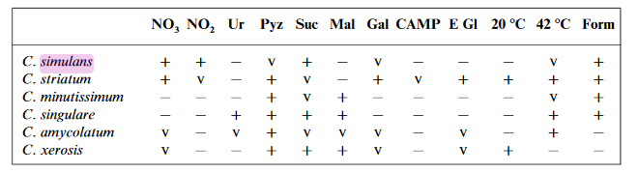
Figure 8: This figure indicates C. simulans result on different kind of tests. (Pierre Wattiau, 2000)
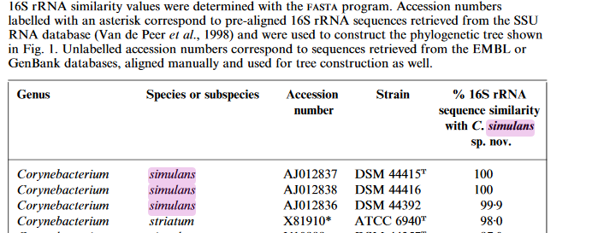
Based on Wattiau and others, C. simulans are closely related to Corynebacterium striatum (Figure 9) (Pierre Wattiau, 2000).
Figure 9: This figure is an excerpt of phylogenetic tree that Wattiau and his colleagues created. It shows that C. simulans most related bacteria is C. striatum (Pierre Wattiau, 2000).
Unfortunately, this information doesn’t really prove anything about the results that I accumulated in lab. Due to the fact that it was a fairly new proposed bacteria, it didn’t have much information regarding its physiological and genotypic data. However, Wattiau and his colleagues have some decent amount of information regarding its structure and some of its properties. In the lab, I tested my isolate as Catalase positive and compared to the literature C. simulans is actually catalase positive. As for gram staining, the literature stated that C. simulans is Gram-positive. Comparing my results, this explains why my isolate did not react or was unresponsive to both Gram-negative API strip tests. As for its Oxygen class, the literature stated that C. simulans is actually facultative anaerobic, which has aerobic and anaerobic properties and has fermentative capabilities. Comparing to my results, my isolate was an obligate aerobe which didn’t really match with what was on the literature.
Going back to my hypothesis, I concluded that my isolate would be one of the most common bacteria that are found at homes, and I predicted that my hypothesis would be supported. However, this is not the case. My isolate wasn’t closely related to the most common ones found, instead my isolate turned out to be a Corynebacterium, a genus that is commonly grouped with the microfloras, or groups of bacteria that are commonly found in human skin (Lee, 2014).
Which makes sense because the environment and the object was fairly visited or inhabited by humans. Skin microbes could potentially get transferred to the objects you interact with every single day. This states that my hypothesis and prediction was actually not supported and that the bacterium that was identified makes sense where it was found.
Finally, I could say that one of the many bacterium that was living on my PS4 was C. simulans and was characterized as Gram-positive bacteria that can utilize Oxygen as its electron acceptor and is facultative anaerobic. Based on the results that I achieved, my results were not that consistent to the literature overall, but some of the tests agree with it. However, I wasn’t able to find any document if C. simulans was susceptible or resistant to those drugs that I tested for. My hypothesis and prediction wasn’t supported due to its identity as being a microflora. As for future projects, I’d like to find more data and literature about C. simulans because it was hard to find peer-reviewed literatures about it. I would also like to test this bacterium with the API Staph test next time, to see if the result agrees with the literature. Also, it would be a great idea to find research papers about C. striatum to compare it with C. simulans since Wattiau proved that they are the most closely related Corynebacterium species out of the new 20 more species he and his colleagues discovered (Pierre Wattiau, 2000). More importantly, I was able to achieve my goal in this project, which was to identify and characterize a bacterium residing on a gaming console.

References
Beware of common household germs. (2014, November 28). Retrieved from NHS choices.
Joseph Mercola, R. D. (2003, December 3). Mercola.com. Retrieved from Mercola (Take control of your health).
Lee, N. (2014, August). Microorganisms found on the skin. Retrieved from DermNet New Zealand.
Madigan, M. B. (n.d.). Brock Biology of Microorganisms. Pearson.
Pierre Wattiau, M. J. (2000). Corynebacterium simulans sp. nov., a non-lipophilic, fermentative Corynebacterium. International Journal of Systematic and Evolutionary Microbiology, 347-353.

