Nathan Taylor
Microbiology 342
4/28/17
Microbes from a Specialized Built Environment
Introduction
The micro biome of the built environment is one that has a large affect on our daily lives. With increased urbanization a study “estimates that humans spend as much as 90% of their lives inside” (Kelley & Gilbert, 2013). There are many different types of built environments and each could have a unique micro biome of its own. Some examples of the numerous built environments include hospitals, homes, apartment complexes, factories, office buildings, and nursing homes (Kelly & Gilbert, 2013).
There has been sufficient research into air quality and the potential causes of pollution of the air inside the built environment (Corsi et. al., 2012). There is less knowledge on the microbes that habitat the built environment along with us (Corsi et. al., 2012). These microbes could pose potential threats to our health and as knowledge of these microbes increase better prevention methods, building design, and building maintenance adapt to the increasing knowledge (Corsi et. al., 2012).
I attempted to isolate, characterize and identify a bacterium from a built environment, specifically a prone mat from the UAF Rifle Range. Once isolated, the bacterial genome was sequenced to further identify the bacterium. I hypothesize that a bacterium from the micro biome from the UAF Rifle Range will be different from that of other micro biomes found in the built environment. I think that the bacterium will be aerobic, and could possibly be chemolithotrophic. Since the microbes are in direct contact with air I think that they will be aerobic. Due to the higher concentrations of heavy metals such as lead the microbe could possibly be chemolithotrophic.
Methods
I swabbed a prone and then streaked the sample on a Tryptic Soy Agar (TSA) plate in order to grow out microbes living in the UAF Rifle Range. The sterile plate was inoculated (Lab 1 Handout) with two samples from the environment. This environmental sample was further isolated (Lab 2 Handout) using aseptic techniques and the quadrant streaking method, and stored in an incubator at 37°C. This was repeated three times to attempt to obtain a pure culture. To start to identify the environmental isolate, a Gram stain was carried out (Lab 4 Handout). This separated the isolate into two categories, Gram positive which has the larger peptidoglycan layer, and Gram negative, which has a smaller or no peptidoglycan layer. DNA was extracted from the environmental isolate using a Powersoil kit (Lab 5 Handout). The DNA extract was sequenced at the UAF DNA Core Lab using an Illumina MiSeq. The DNA sequences were analyzed through the BaseSpace cloud-computing tool utilizing multiple applications provided. The SPAdes Genome Assembler was used to assemble the partial genome of my isolate. The taxonomy was assigned using Kraken Metagenomics. Then the Prokka Genome Annotation was used to annotate the functional genes, to aid in the identification of the isolate.
Multiple physiological tests were performed on the isolate including: a fluid thioglycollate test, an oxidase test, a catalase test, and the API 20 E Test Strip, which contains a series of different tests (Lab 6 Handout). These tests helped to determine oxygen class, the presence of cytochrome c oxidase, the presence of catalase (releases O₂ from reactive oxygen species), 21 metabolic processes and antibiotic susceptibility.
Results
Gram Stain:
Under a microscope my isolate was recorded as Gram variable, which is considered Gram positive. A pure culture that is gram variable, contains new cells that are were gram negative but will become gram positive once they complete development.
The colony was light yellow in color and formed small round convex colonies with a glossy exterior (Figure 1). The colonies, once isolated, were one to two millimeters in diameter. The cells were streptococci in shape ranging from singles and tetrads to large clusters (Figure 2).
Genomic Analysis:
Genomic data was inconclusive at determining the identity of the microbe.
Physiological Traits:
Catalase Test: Positive
This test looks for the presence of the enzyme catalase. This enzyme protects the bacteria from reactive oxygen species by decomposing hydrogen peroxide to water and oxygen.
Fluid Thioglycollate, Oxygen Class: Aerobic
This test finds the oxygen class of the microbe by allowing it to grow in different concentrations of oxygen.
Api 20E Test Strip Results: (Figure 3)
The microbe tested positive for the SAC test, meaning that it has the ability to ferment sucrose. It also tested positive for the Voges-Proskauer (VP) test, which detects acetoin produced when glucose is fermented by the butylene glycol pathway.
The microbe tested negative for the rest of the tests including the H2S, CIT, and MAN tests. The H2S test detects the production of hydrogen sulfide. The CIT test determines if citrates can be utilized as a sole carbon source. The MAN test, tests if the bacteria can ferment mannose.
Antibacterial Test:
Antibiotic | Zone of Inhibition Diameter | Response
Erythromycin | 25mm | Susceptible
Oxacillin | 34mm | Susceptible
Tetracyoline | 46mm | Susceptible
Clindamycin | 10mm | Resistant
Amikacin | 30mm | Susceptible
Piperacillin | 42mm | Susceptible
Vanctomycin | 32mm | Susceptible
Gentamicin | 40mm | Susceptible
The microbe was susceptible to all but one of the tested antibiotic (Figure 4). Clyndamycin inhibits the production of key proteins needed to spread the infection throughout the host (Shenvi, 2015). It binds to the large subunit of the ribosomal subunit of the bacteria preventing the formation of new peptide-peptide bonds (Shenvi, 2015). The zones of inhibition overlapped around most of the antibiotics, but there was enough distinction between the zones that an accurate diameter was taken.
Discussion
After completing genomic and physiological tests a definitive isolate could not be determined, though the tests did corroborate the identity of Kocuria rhizophila . Genomic testing was inconclusive due to two factors: a contaminated isolate and a narrow database. The physiological testing did not help to narrow the findings very much. According to the Kraken Metagenomics database, Kocuria rhizophila, was the best match (Figure 5). However, even though a match was found, the quality of the match was not good enough to solely support K. rhizophila as the identity of the isolate. However, the phenotypic results of the isolate do not contradict the genotypic test identifying K. rhizophila. There were many phenotypic tests that matched the characteristics of K. rhizophila. (Public Health England). The color, shape and texture of the isolate were consistent with K. rhizophila. The yellow, shiny smooth texture of the isolate is characteristic of K. rhizophila as well as the cell size and Gram-positive staining results. The thioglycollate and Oxidation and enzyme tests were also both consistent with what you would expect for K. rhizophila. (Public Health England)
K. rhizophila was used during other labs and found growing in the sterile cultures used for the environmental isolation so it is difficult to say whether I sequenced a contaminant or if this bacterium was actually derived from where I initially sampled.
The small fraction of the genome that was sequenced and matched makes it difficult to use as a reliable source. Only 55.32% of the reads were classified to the domain level, and 43% of the reads were unclassified. Of the reads that were classified to the domain level only 26% were classified as K. rhizophila (Figure 5). If I had had more time, I would have ran the sequences through additional databases and re-streaked the original culture to find out the identity of the microbe.
Even though the phenotypic data supports the genotypic data, the evidence for a more conclusive statement with regard to identity was not provided in this study. It is unclear if K. rhizophila was the original isolate, but since the genotypic data is inconclusive a conclusion could not be reached. In the future I would make sure that all agar plates are contaminate free before adding the isolate to the plate. Also, I would collect more than one genome sample to run so that there would be more than just one genome test. The phenotypic tests were done before the realization of a contaminate, in the future I will make sure that the isolate is pure before phenotypic tests are run. Additionally after the realization of a contaminate, I will re-isolate the original culture before moving forward to genotypic and phenotypic tests.
Works Cited
Corsi, Richard L., Kerry A. Kinney, and Hal Levin. "Microbiomes of built environments: 2011 symposium highlights and workgroup recommendations." Indoor air 22.3 (2012): 171-172.
Glass, Elizabeth M., et al. "MIxS-BE: a MIxS extension defining a minimum information standard for sequence data from the built environment." The ISME journal 8.1 (2014): 1.
Kelley, Scott T., and Jack A. Gilbert. "Studying the microbiology of the indoor environment." Genome biology 14.2 (2013): 202.
MD, PhD Christina Shenvi. "The Clindamycin Fact Sheet." Medpage Today. MedpageToday, 20 Sept. 2015. Web. 25 Apr. 2017.
Public Health England. "Bacteria detail." Bacteria Collection: NCTC 8340 Kocuria rhizophila. Culture Collections, n.d. Web. 11 Apr. 2017.
Purty, Shashikala, Rajagopalan Saranathan, K. Prashanth, K. Narayanan, Johny Asir, Chandrakesan Sheela Devi, and Satish Kumar Amarnath. "The expanding spectrum of human infections caused by Kocuria species: a case report and literature review." Nature News. Nature Publishing Group, 01 Oct. 2013. Web. 11 Apr. 2017.

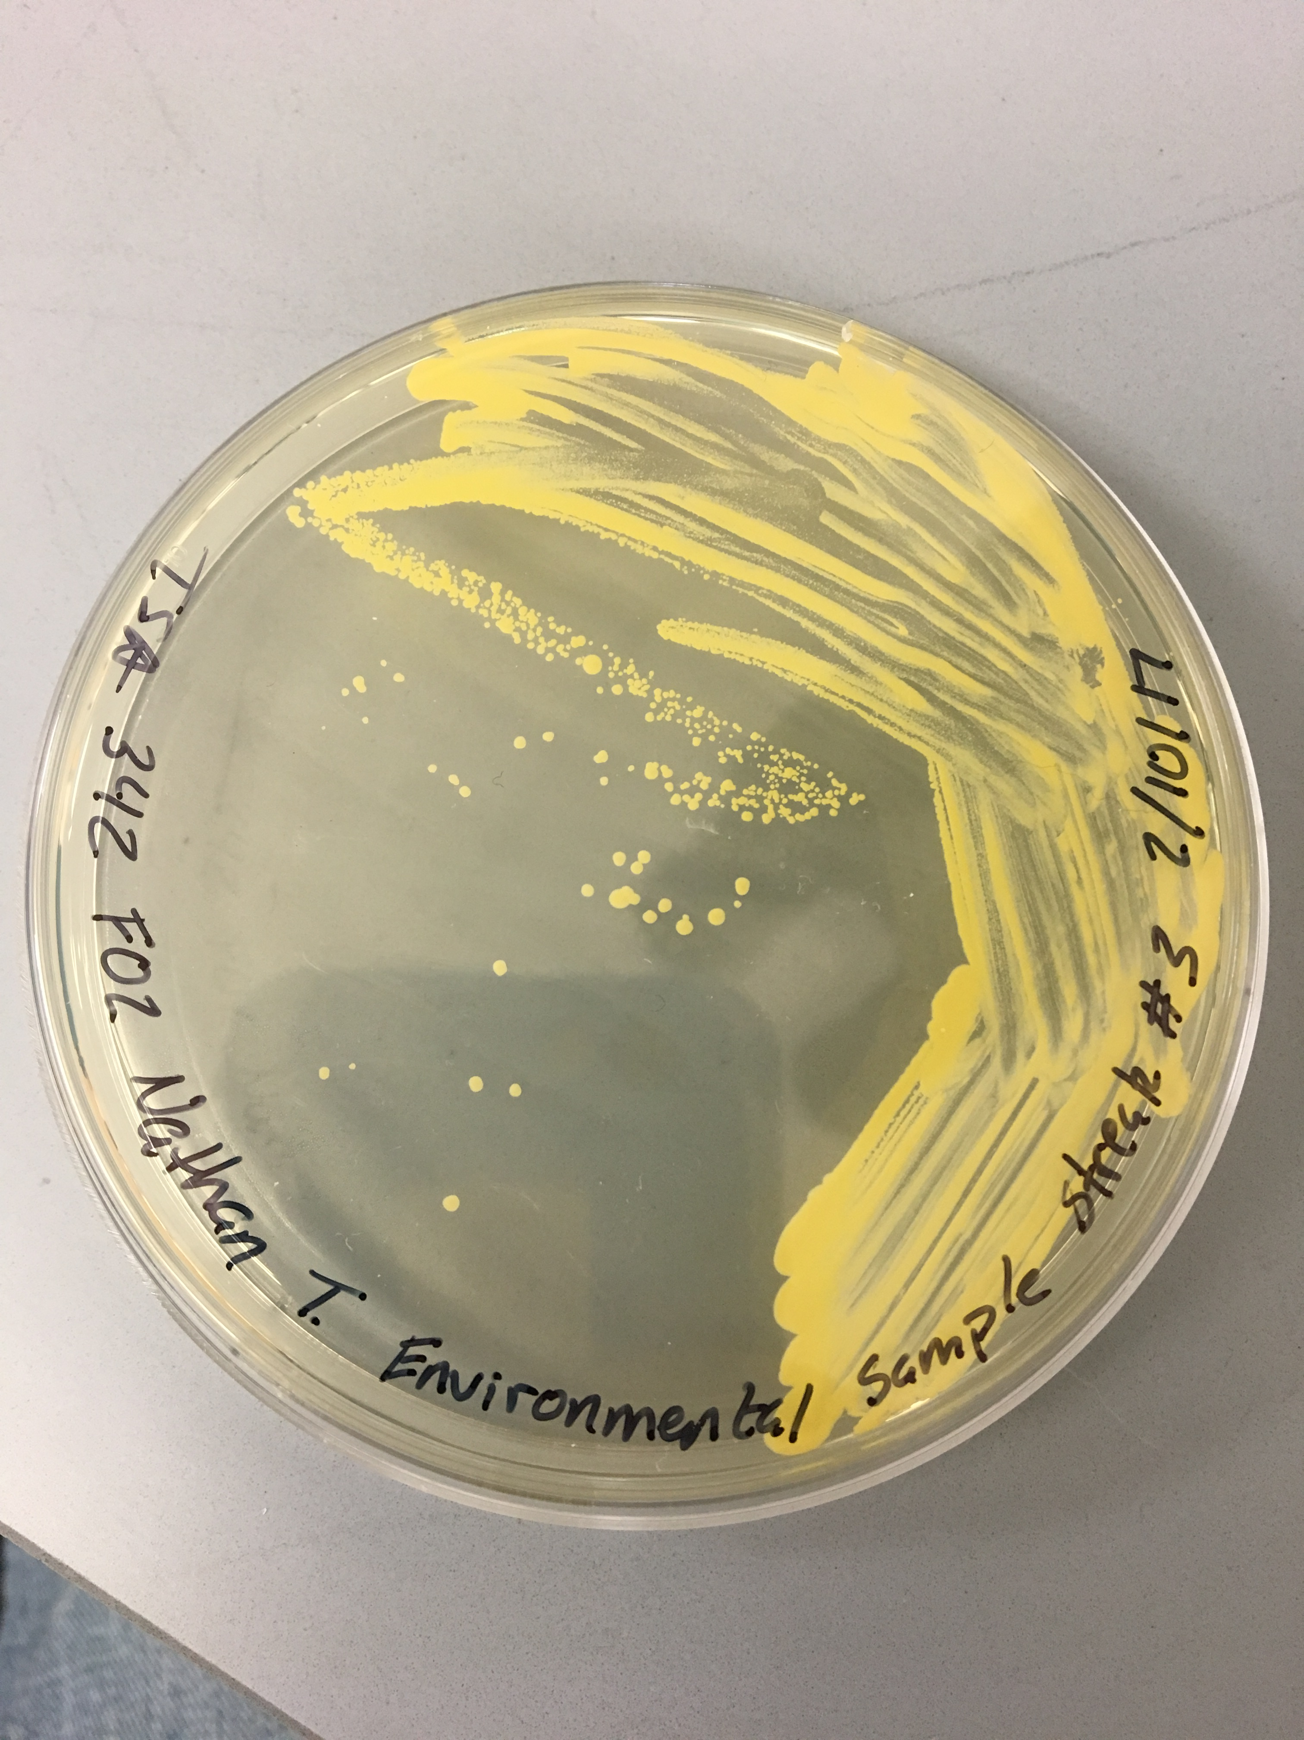
Figure 1.
Quadrant streak of environmental sample on a TSA plate, incubated at 37°C.

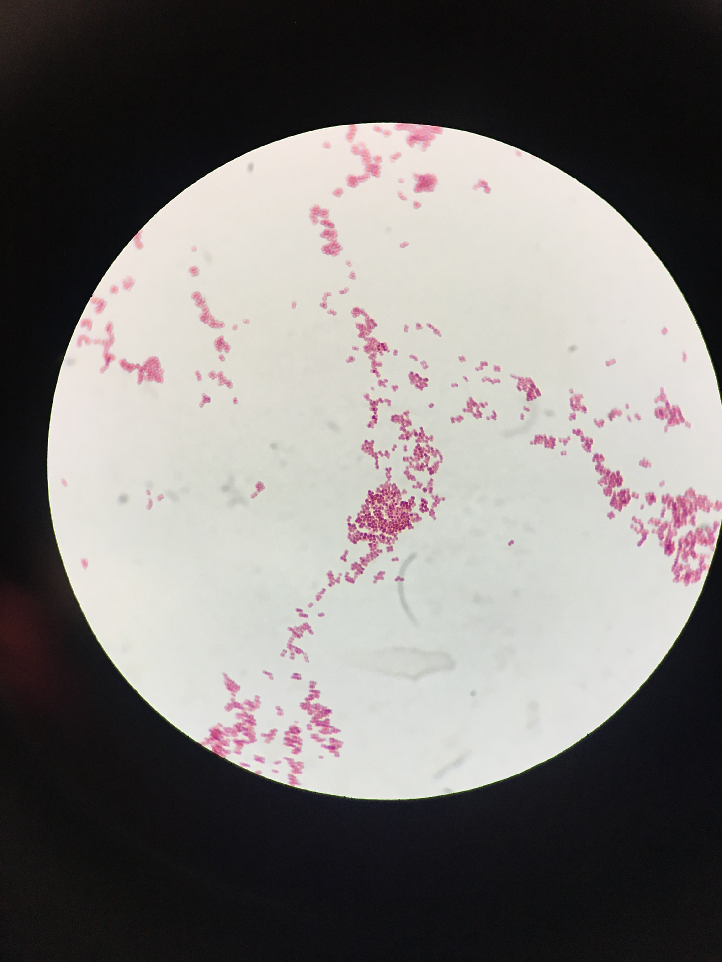
Figure 2.
Gram stain and cell morphology of the isolated sample under the microscope.

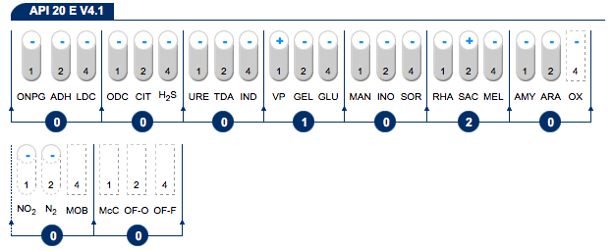
Figure 3.
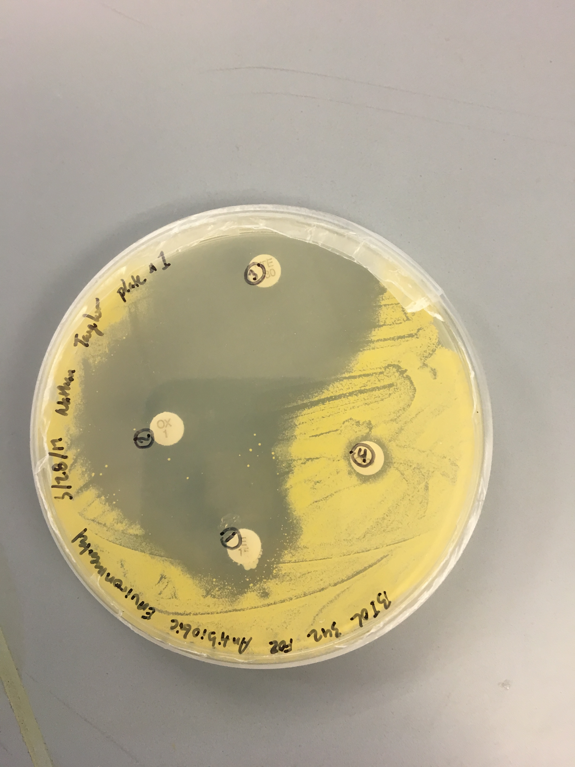
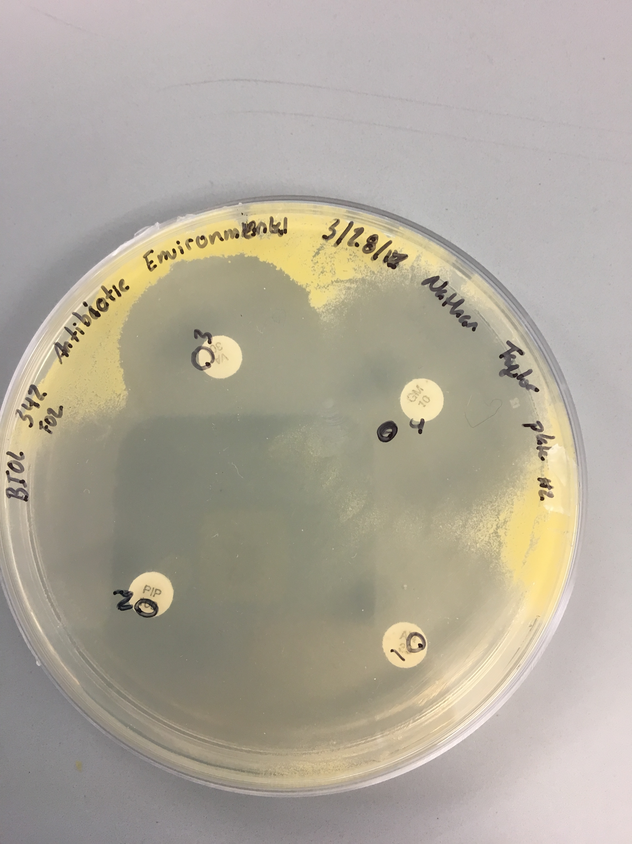
Figure shows, API 20E Test strip with positive and negative results. Four tests were not completed. Since all test were not completed, positive identification cannot be achieved from the API analysis database.
Figure 4.
Antibacterial test plates.
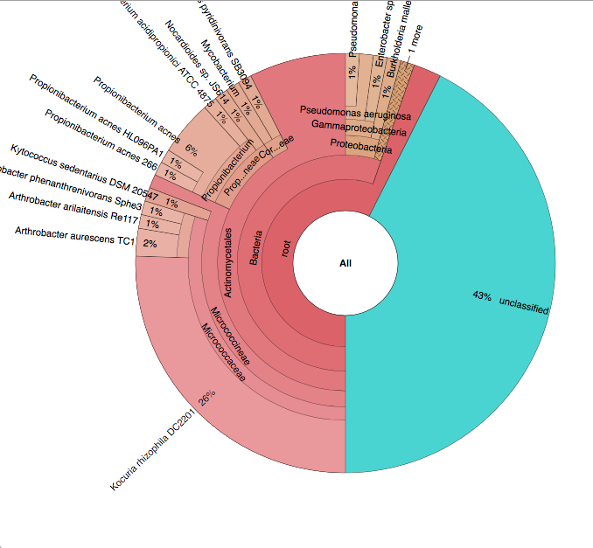
Figure 5.
Krona classification chart of isolate. Shown from the domain level to the species level.

