Sandra Kolberg
Dr. Leigh
BIOL342 Microbiology
April 13th, 2017
Bacterial Isolate Project: What Lives on the Bottom of my Backpack?

Picture this: You’re a microbe; free to live anywhere your little cellular body can take you. But where would you choose? Somewhere warm, dark, and oxygen-rich? Or maybe somewhere colder, darker; a place where the human giants around you could not survive. The truth is a microbe’s environment of choice varies with its metabolic needs. Though a lot of microorganisms can technically survive in many environments, for one to truly thrive it must find a habitat that matches its physiological needs. With this idea I chose to streak the bottom of my backpack for my bacterial isolate project. Though this environment is similar to many oxygen-rich habitats on this Earth that microbes could reside, it seems like the bottom of my backpack offers little nutrients for bacterial growth. I was curious to see the amount and variation in growth, as any bacterial growth on my backpack must be pretty resilient and low-maintenance. I took a sample from the bottom of my backpack and ran a series of physiological and genetic testing to see if the bacteria I isolated matched the characteristics required to survive in such a place. Depending on the places my backpack was set, results could be interesting.
To identify the bacterial isolate taken from the bottom of my backpack, a number of physiological and genetic testing was performed. This process began after I isolated my bacterium into pure culture across multiple generations of tryptic soy agar (TSA) plates. To ensure sterility and prevent contamination of my isolate, I streaked each plate using aseptic technique. After I was fairly certain as to the purity of my cultures, I could begin identification testing.
My first test was to determine whether my bacterium was Gram-positive or Gram-negative. We started by heat-fixing our isolates to a clean microscope slide. After this step came a series of differential stains: Crystal violet, Gram’s iodine, ethanol, and Safranin. The thick peptidoglycan layer dehydrates from the ethanol, trapping the purple stain inside the cell; the cells then appear purple under the microscope. Gram-negative cells appear pink, as their peptidoglycan layer is thin.
My next test was genetically based. Using a liquid culture in tryptic soy broth (TSB), we extracted the DNA of our isolate using a Power-Soil DNA isolation kit and protocol. This process involved lysis of the cell, removal of inhibitors and proteins, and obtaining a pure solution of DNA. Once this DNA was extracted, I sent my sample for sequencing at the DNA Core Lab. The sequencer used was the Illumina MiSeq DNA sequencer. After our results got back, I ran a series of programs using BaseSpace in order to identify my bacterium. These programs included the Prokka Genome Annotation app (which identified the number of contigs and tRNAs found overall in my sample), the Kraken Metagenomics app (which matched found sequences to bacterial strains in a database), the SPAdes Genome Assembler (which gave more information as to the number of contigs and the read length of my sample) and the BLAST database to confirm the identity of my isolate. A combination of this genomic and physiological testing ultimately helped me infer the true identity of my isolate.
For Lab 6, I began extensive physiological testing with my bacterium. The first test I did was the fluid thioglycollate test, which was done to determine oxygen class of my organism. The next test I did was the oxidase test. This was used to determine whether or not my isolate strain had cytochrome c oxidase.
The next test we performed was the catalase test, which tests the strain for the presence of catalase. The catalase enzyme catalyzes the release of oxygen from the reactive oxygen species hydrogen peroxide. The last test we prepared during this lab was actually a multitude of tests in one strip: The API test strip, which tests for 21 different physiological characteristics.
The last physiological test completed on my isolate was for antibacterial resistance. By creating a lawn of bacteria on multiple TSA plates, I was able to test my isolates’ susceptibility to specific antibiotics released on the plate from small paper disks. If the bacteria were susceptible, growth around the disk would be stopped creating a zone of inhibition. By measuring the diameter of these zones after an 18-24 hour period, the identity of my bacterial strain could potentially be revealed by referencing the chart attached to this lab; specific antibiotics induce a distinctive zone of inhibition for different species of bacteria. All of this information gathered from these physiological and genetic-based tests helped me to determine the identity of my isolate.

The first physiological test was Gram-staining. This test revealed that my bacterial isolate is Gram-positive, spherical in shape, small, and formed clusters with
other cells (Figure-1).
.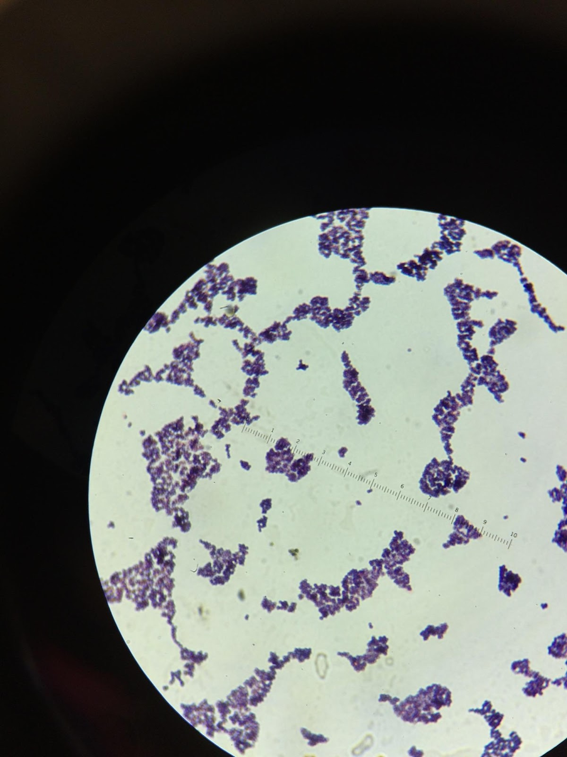

Figure-1; Picture taken of my isolate in Microscope lens after staining.
Various other physiological tests revealed critical information in identifying my isolate. The fluid thioglycollate test showed growth at the surface and about a centimeter and a half underneath the pink layer at the top of the medium. This indicates that my bacterium is a facultative anaerobe. The oxidase test revealed that my isolate was positive for having cytochrome c oxidase. The catalase test was positive indicating the presence of the enzyme catalase.
The next physiological testing I performed involved the API 20E test strip. If this test had worked for my strain, it would have revealed 21 different physiological characteristics. Unfortunately, this particular strip type was meant for Gram-negative bacteria and my isolate was Gram-positive; all of the tests turned out negative for my sample (Figure-2). I tried this procedure a second time using an API Staph test strip. This set of testing revealed that my isolate was positive (able to undergo aerobic acid formation) for glucose (GLU), fructose (FRU), maltose (MAL), D-mannitol (MAN), Sodium Pyruvate (VP), D-sucrose (SAC), L-Arginine (ADH), and Urea (URE). An image of this successful strip can be seen in Figure-3.
Figure-2; all test results from the API 20E test were negative.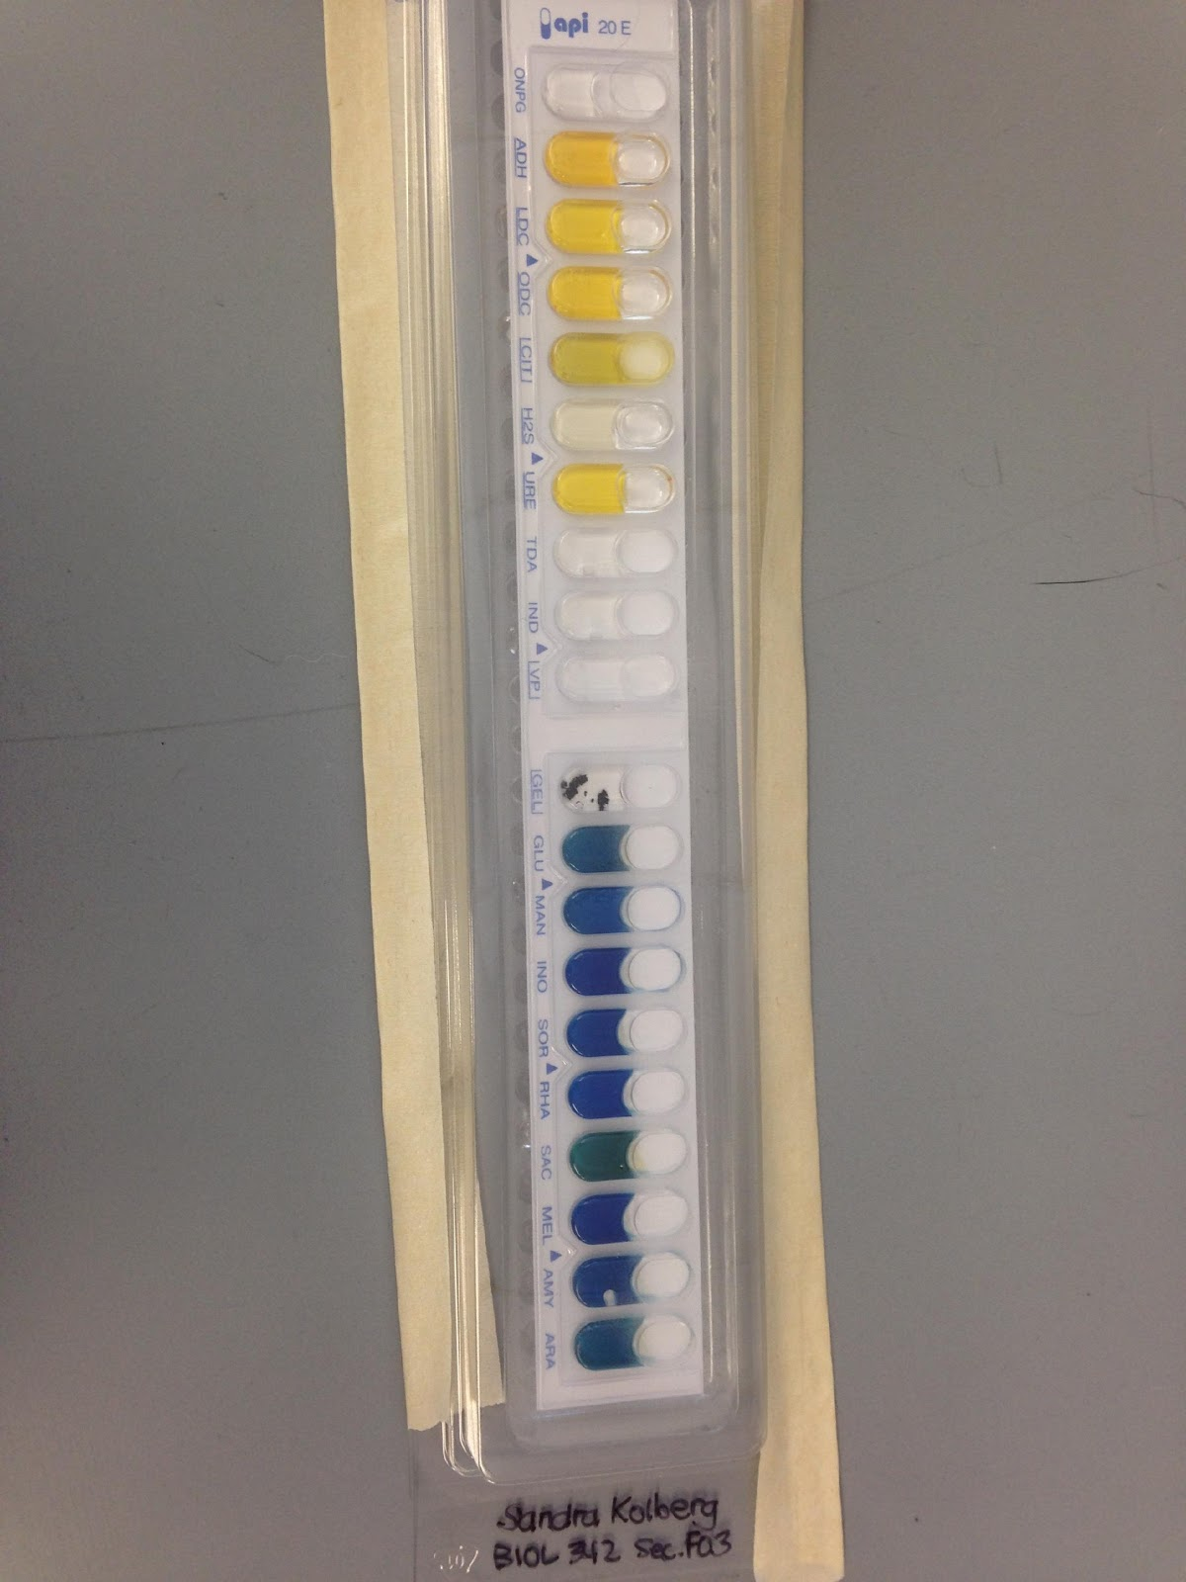
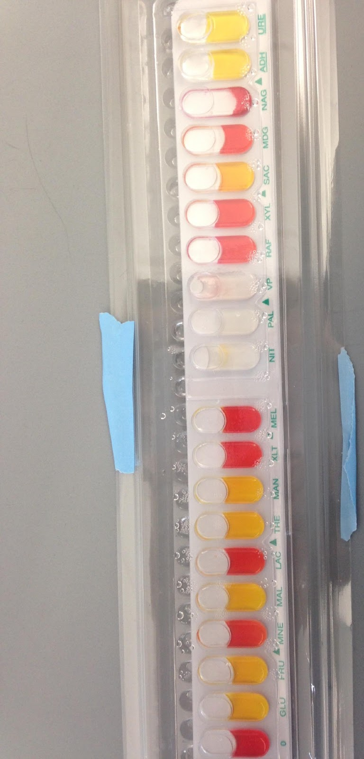
Figure-3; successful API Staph test strip (yielded positive results).
One of the biggest indicators as to the identity of my species came from genomic sequencing completed by the illumina MiSeq sequencer and analyzed using BaseSpace. Analysis using the Prokka Genome Annotation program revealed that the longest sequence in my whole sample was 292,497 bp long. There were only 470 contigs total and two recognized tRNAs. The Kraken Metagenomics program showed that my sample had a total of 5,835 reads, 441 (7.56%) of which were classified. The remaining 92% of the sequences were considered unclassified. Of the 8% that were classified and recognized as identifiable species, I had approximately 23 different possible options for my bacterial isolate. Two species however, had by far the highest percentage of recognizable sequences: Macrococcus caseolyticus (30%) and Enterococcus faecalis (26%). Macrococcus caseolyticus is from the Family Staphylococeae and Enterococcus is from the Family Enterococeae. To confirm the identity of the culture I isolated, I ran the raw data from the Kraken Metagenomics application through a database called BLAST.
The last physiological test that we did was for antibiotic resistance. Unfortunately, my plates did not yield a visible microbial lawn, therefore the zone of inhibition was immeasurable.
After determining that my isolate was Gram-positive and formed clusters with other cells of its kind, I hypothesized that my bacterium was of the Staphylococcaceae family. Without genomic analysis of my isolate, I had no way of confirming this theory and the results of my physiological tests correlated with many different strains outside of the Staphylococcaceae family. After DNA isolation and sequencing however, genomic analysis revealed that a strain of Staphylococci was a possibility. Though promising in supporting my hypothesis, genomic testing added uncertainty; 92% of the gene sequences in my sample were unclassified. Only 8% of the sample analyzed by the MiSeq sequencer matched the database, and of that 8%, I had over 20 different possible strains, indicating a high degree of contamination. I chose to research the two strains that had the highest percentage of matching my isolate. The information I sought in researching these strains involved the physiological tests done earlier. My isolate was positive for cytochrome c oxidase, catalase, was a facultative anaerobe, and had failed the Gram-negative API 20E strip which confirmed that my strain was Gram-positive.
The first strain I researched was Macrococcus caseolyticus, a relative of the Staphylococcaceae family. Previously included in this family, Macrococcus was assigned its own Genus “because of its distinctly smaller genome size” (Baba 2). Unlike Staphylococci, Macrococci are non-pathogenic and can typically be isolated from the skin of animals and from food such as meat or milk. According to www.vumicro.com, Macrococcus caseolyticus is “Gram-positive…and is found in pairs or clusters”. The site states that this strain is a facultative anaerobe and catalase positive. Macrococcus caseolyticus is also positive for cytochrome c oxidase (Wikipedia.org). Their cellular morphology is supposedly slightly larger than that of Staphylococci.
The other bacterial strain genomic analysis revealed as the possible identity of my isolate was Enterococcus faecalis. A normal part of the human intestinal microbiome, Enterococcus species are facultative anaerobes that “are distinguished by their morphological appearance on Gram stain…(Gram-positive cocci that grow in chains” (emedicine.medscape.com)). Sugars metabolized by E. faecalis are D-glucose, D-fructose, lactose and maltose (microbewiki). E. faecalis “does not produce a catalase reaction with hydrogen peroxide”, and it shows consistent growth with an aerotolerant species (Wikipedia). Based on its difference in colony morphology, its lack of catalase enzyme, and its oxygen class, the Enterococcus faecalis species seems unlikely to be the identity of my bacterial isolate. This however is not guaranteed, as my genomic data indicates high levels contamination.
The results of my polyphasic approach in identifying the bacterial isolate culture from the bottom of my backpack came out interesting and somewhat inconclusive. Knowing that the API 20E test strip was negative, I used the API Staph test strip to obtain more information on my isolate as this is the strip recommended by the manufacturer for Gram-positive, catalase-positive microbes. With the other data obtained, I was hoping to support the Staphylococci hypothesis, as well as confirm either Macrococcus caseolyticus or Enterococcus faecalis as the identity of my isolate. This test yielded multiple positive results, indicating that my isolate was or was closely related to the Staphylococcaceae Family.
If the test only requires species closely related to Staph, then the Macrococcus species is the most likely identity. This idea is supported even further by the results of my physiological tests, as well as further genomic testing done using the BLAST database. When I processed the raw contig data found with Kraken Metagenomics in BLAST, there was a 94% match to Macrococcus caseolyticus and a 92% match to another strain of Macrococcus. Though limited, there are resources that described characteristics of Macrococcus that corresponded to my isolate. This bacteria, initially regarded as a member of the Staphylococcaceae Family grows unpigmented or pale yellow colonies; My isolate’s colonies were pale yellow. Macrococcus caseolyticus is “isolated mainly from raw cow milk and dairy products (surface cheese bacteria), also from reptiles’ saliva (komodo dragon)” (www.tgw1916.net). Other than the fact that this microbe is a facultative anaerobe and the bottom of my backpack has a readily available supply of oxygen, I’m not sure where this strain came from or why it is thriving in this environment. It is very interesting to see the diversity of the growth in such an unassuming place.

References:

Websites:

http://www.vumicro.com/vumie/help/VUMICRO/Macrococcus_caseolyticus.htm
https://en.wikipedia.org/wiki/Macrococcus

Scientific Article(s):

Baba, Tadashi, and Kyoko Kuwahara-Arai. "Complete Genome Sequence of Macrococcus caseolyticus Strain JSCS5402, Reflecting the Ancestral Genome of the Human-Pathogenic Staphylococci." Journal of Bacteriology 191 (2009): n. pag. American Society of Microbiology. Web. 27 Apr. 2017.

