Identification and Characterization of Bacillus amyloliqueficans From Sink Drain
By Torie Leach
Introduction
Sinks provide a lot of opportunities for bacteria to grow, especially if a sink is being used for more than just hand-washing. People use sinks to wash their dishes, sending old pieces of food down the drain; brushes coated in paint; skin cleansers. All of these items provide ample opportunity for a variety of bacterial strains to grow and thrive. A lot of studies have been focused on the sinks found in medical facilities, most commonly hospitals, finding pathogenic and antibiotic resistant bacteria (Abrahamsen et al., 1989). Among these studies, researchers have also found that the formation of biofilms contribute to survival of bacteria in sinks and increase antibiotic resistance, especially in the hospital environments (Moffet and Williams, 1967). On the other hand, there have not been a plethora of studies focused on the types of bacteria found in household sinks. Studies conducted in households look at effects of cleaning (Rusin et al., 1998) or microbial diversity between multiple households (Dunn et al., 2013). There does not appear to be a lot of studies focused on types of bacterial strains found in sinks within households unless the study addresses a topic of public concern: disease-causing bacteria.
The main idea behind this project was to identify a single bacterial strain from a location, such as the sink, through various physiological and genetic tests. The bacteria for this project most likely came from the water because water is the one things that is consistently going down the drain and running over the top of the sink drain plug. Having water run over the location where the sample was taken from can easily wash bacterial strains down into the drain. This could lead to one bacterial strain being the strain that dominates against all other potential strains. Ways to determine strain-type and if there is only one strain that were carried out in this project are isolating the bacteria using quadrant streaks, staining, other physiological tests, and genomic sequencing. All of these tests would quickly confirm one type of bacterial species found in this location.
After isolating the bacterial strain taken from the sink drain and carrying out the different tests, the species found was Bacillus amyloliqueficans. This species of bacteria is commonly associated with plants and defending those plants from pathogens in order to encourage growth (Mendis et al., 2016). Many researchers have found Bacillus amyloliqueficans to protect and block against specific pathogens depending on the plant (Tan et al., 2016, Soares et al., 2016). With that being said, Bacillus amyloliqueficans is typically found in soil because it helps facilitate plant growth (Molohon et al., 2011), but it can also be found in aquatic environments (Zhang et al., 2016). Overall, Bacillus amyloliqueficans is considered to be a beneficial bacterial species when it comes to plants.
Methods
Inoculation and Pure Culture Isolation
TSA and SA plates were inoculated, as described in Lab 1 Handout, to see how different microbes grow based on the media they were in. The sample was obtained from the top of the sink drain plug and TSA and SA plates were kept under the sink at room temperature one week before being taken in the lab. Although colonies on the TSA plate were not very isolated from one another, a small portion of the dull, white, filamentous colony was selected from the original inoculated plate, this colony was streaked onto a new TSA plate following the streak plate method in order to obtain a pure sample of the bacterial isolate (Lab 2 Handout). This plate was stored in the 37°C incubator for approximately 2 days before being checked and re-streaked three times following Quadrant Streak method (Lab 2 Handout) in order to make sure the isolate is as pure as it can be in order to be ready for identification tests.
Gram Stain
The Gram-stain was carried out as described in the Lab 4 Handout in order to conclude whether the isolate was Gram-negative, Gram-positive, or Gram-variable.
DNA Extraction, Sequencing and Analysis
Using a sample from the liquid culture containing the isolate, DNA extraction was carried out using the PowerSail DNA isolation protocol from Lab 5 Handout in order to analyze the results from liquid culture of the isolate.
Once results were obtained from the DNA Core Lab, the genome sequence was analyzed using BaseSpace. The isolate’s genome was assembled using the SPAdes Genome Assembler on the BaseSpace website by following the protocol described in the Lab 7 Handout. This was done to find out what genes are in the isolate, as well as what those genes do depending on assembled contigs and scaffolds (Lab 7 Handout). To identify the isolate to the species or genus level, Kraken Metagenomics was used to match with a database and to also use the 16S rRNA sequence as a way to identify the isolate (Lab 7 Handout). Prokka Genome Annotation was used to annotate genes and determine their function using the results from genome assembly (Lab 7 Handout). For both Kraken Metagenomics and SPAdes Genome Assembler, the sequence obtained from the DNA Core Lab was uploaded to BaseSpace and used (Lab 7 Handout).
Physiological Testing
A fluid thioglycollate test was carried out using the stab method, incubated at room temperature, and checked 5 days after incubation (Lab 6 Handout). A catalase test was done by placing 3% hydrogen peroxide on a microscope slide and then mixed a small amount of the isolate from the plate to see if there was any reaction that indicated if the isolate has catalase (Lab 6 Handout). This enzyme is important because it catalyzes release of oxygen from hydrogen peroxide (Lab 6 Handout). An oxidase test was performed to figure out if the isolate has cytochrome c oxidase (Lab 6 Handout). For this test, a plastic loop was used to obtain some of the bacteria from the plate and that sample was smeared on the test strip that changes color if the bacteria is positive or negative for having cytochrome c oxidase (Lab 6 Handout). An API 20E test strip was used to test for 21 physiological traits, such as being able to ferment glucose and lactose and ferment other compounds (Lab 6 Handout). An isolated colony from a streak plate containing the isolate was mixed in 5 mL API buffer to obtain homogeneous suspension and were placed in the tubes according to the Lab 6 Handout. The tray was filled with approximately 5 mL of distilled water which made a humid atmosphere, and was placed in 37°C incubator for 3 days where follow-up tests were performed if 3 of the tests were positive (Lab 6 Handout). The TDA test had 1 drop of TDA reagent added that would change color from clear to reddish brown for a positive reaction; 1 drop of VP1 and VP2 were added to the VP tube, and after 10 minutes, a color change from clear to a pink/red meant the reaction was positive; 2 drops of JAMES reagent were added to the IND tube, and a color change indicated a positive reaction (Lab 6 Handout). In GLU tube, nitrate reduction test was carried out to determine if the isolate was able to reduce nitrate where 1 drop of NIT1 and NIT2 reagents were added to GLU tube followed by addition of 2-3 mg of Zn particles (Lab 6 Handout). The reaction from Zn particles shows whether denitrification was completed (Lab 6 Handout).
Antibiotic Susceptibility
A TSB was inoculated prior to this test. Two agar plates had their entire surfaces inoculated using a swab that had been dipped into the broth culture (Lab 9 Handout). Tetracycline, Amikacin, and Erythromycin antibiotic disks were placed on the surface of one agar plate; Cefazolin, Cefoperazone, and Trimethoprim were placed on the second agar plate (Lab 9 Handout). Both agar plates were incubated at 37°C until the lawn was grown (Lab 9 Handout). Diameter of the zones were measured in millimeters using a metric ruler and those results were compared to the table provided in the Lab 9 Handout.

Results
The bacteria grew really slowly after streaking the TSA plate, however growth increased when placed in a warmer and darker environment (Figure 1). The isolate streaks obtained a pure culture (Figure 2). The Gram stain indicated that the isolate was Gram variable, having a mix of Gram positive and Gram negative (Figure 3). The oxidase test had a positive reaction, as shown by the purple spot on the test strip (Figure 4). However, the catalase test ended up with a negative result as there was no reaction. There were several tests that came back positive in the API 20E test strip: ADH, LDC, CIT, VP, GEL, GLU, MAN, INO, SOR, RHA, SAC, MEL, AMY, ARA (Figure 5). The isolate only grew at the top of the fluid thioglycollate tube, indicating that the isolate was a strict aerobe (Figure 6). Genomic sequencing came back identifying the isolate as Bacillus amyloliqueficans based off of a high percentage of the reads being classified to the species level (Figure 7). Also, there was a large number of contigs (>1,000) in assembly, 1300, and the number of coding regions in assembly was 3,184 (Table 1). BaseSpace identified nucleoid associated protein Cthe_2143, uncharacterized ABC transporter ATP-binding protein Yx1F, probable amino-acid-binding protein YxeM precursor as some of the functional genes in the isolate (Table 1). For the antibiotic susceptibility test, Bacullis amyloliqueficans came back as being susceptible to Amikacin and Erythromycin, and intermediate to Tetracycline (Table 2). There was no growth on the second TSA plate (Figure 8).
Discussion
The bacteria appeared to have a cream color and was all joined together with no isolated colonies; it seemed to have an irregular form with rhizoid portions that are more in the middle of the colony or colonies (Figure 1). The isolate appeared to be motile because in every quadrant streak, there were no isolated colonies (Figure 2). The bacteria also appeared to have a lobate margin and was dull (Figure 1) and was rod-shaped and approximately 1.5 μm as indicated by the Gram-stain (Figure 3). Overall, the shape, oxygen, as well as the thought that the isolate may be motile is consistent with what researchers found (Borriss et al., 2011). Gram-stain results from this experiment was consistent with what was found in another study (Clark et al., 2014). However, catalase test results differed because other researchers found catalase positive (Borriss et al., 2011, Kim et al., 2017). Other researchers obtained positive results from the API 20E test strip from these tests: ONPG, citrate, VP, GEL, and nitrate (Logan and Berkeley, 1984), which was fewer than what was found in the experiments performed on this particular isolate. The genetic testing resulted in a high certainty of the identity of the isolate, meaning that there is little possibility of this isolate being another species (Figure 7). 88.97% of reads were classified (Figure 7) and BLAST found a 100% match. Despite these differences, another study found that Tetramycin had some effect on Bacillus amyloliqueficans, which is similar to what was found on the test performed on this isolate (AlGburi et al., 2016). Also, the fluid thioglycollate results for my isolate matched with what other researchers found for Bacillus amyloliqueficans, which was strict aerobe (Borriss et al., 2011). Even though there may be a lot of tests that had results differ between other studies and the isolate obtained from the sink.
Some of the hypotheses for all of these tests were proved wrong. The differences in results found in the tests performed for this isolate and what other researchers found about Bacillus amyloliqueficans indicate that not every sample of Bacillus amyloliqueficans is going to be the same genetically and physiologically. This means that this bacterial species is going to change its genes and its appearance to maximize chance of survival and ability to thrive, and can depend on what environment the sample is from too. Also, the differences between other researchers’ results and the results found here could be potentially due to contamination at some point from another microbe. There were other microbes being tested on the same time that this organism was being examined and the other microbes could have travelled through air and got into whatever medium was being used on this isolate. However, some tests may have sat too long before the results were obtained due to time conflicts, so that could have effected how the results turned out too. Despite the mismatch in results, there was high genetic certainty mentioned in the results, the morphology and appearance matched, and there were some other physiological tests that had matching results such as the fluid thioglycollate test. The positives found in this experiment provides a lot of confidence as to what the isolate’s identity is because of how well each test matched for the tests with matching results.
As mentioned in the results, the second plate for the antibiotic susceptibility test showed no growth (Figure 8). The lack of growth could have occurred because the sample of Bacillus amyloliqueficans may not have had enough time to grow in the TSB tube, so there was not enough of the sample to successfully grow on the plate. This indicated that this particular sample of Bacillus amyloliqueficans needed a lot of time to grow to ensure strong test results.
Bacillus amyloliqueficans is usually found in a certain type of environment. The particular Bacillus species if typically found in soil and aquatic environments to name a couple (Zhang et al., 2016). However, this bacterial species is associated with helping plants grow, as mentioned previously, because this bacterium provides antibiotic protection (Zhang et al., 2016). The sink must have carried the appropriate growing temperature and pH, as well as a suitable surface to promote Bacillus amyloliqueficans growth (Monteiro et al., 2016). This, and all of the tests that were described previously, shows that B. amyloliqueficans can inhabit another type of environment besides soil.

Tables and Figures
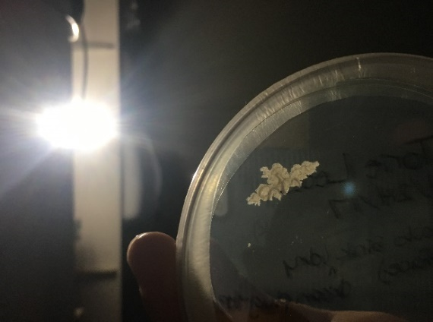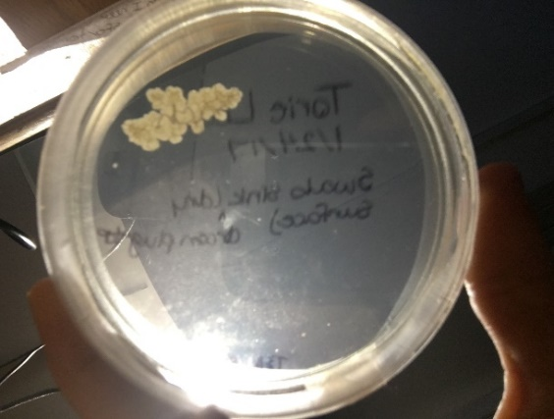
Figure 1: The picture on the left is after approximately 2 days after swabbing the TSA plate. The picture on the right is growth after approximately one week.
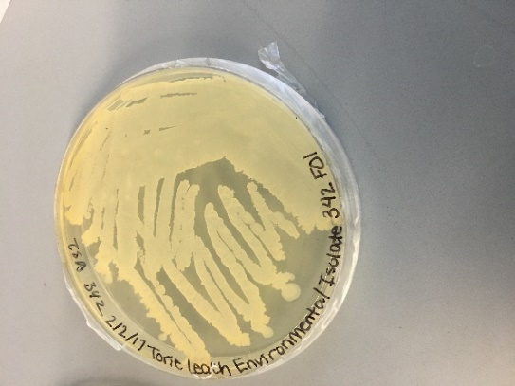
Figure 2: Quadrant streak performed on the isolate to obtain a pure culture.
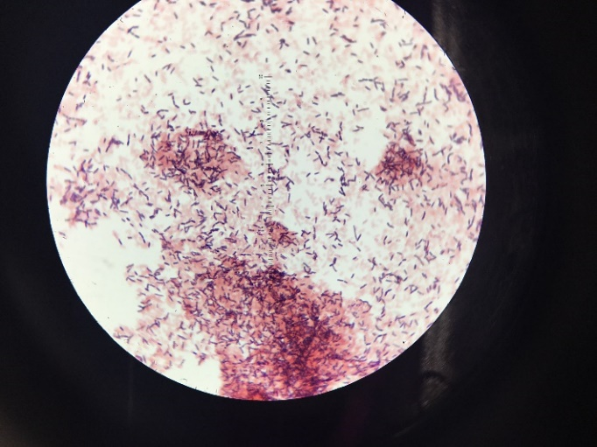
Figure 3: Results of the Gram stain, which is Gram variable observed under 100X magnification with a light microscope.
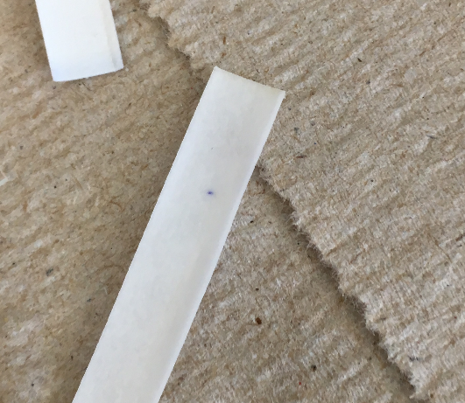
Figure 4: Results from the oxidase test. The small purple spot on the test strip indicates a positive result.

Figure 5: There are insert number of positive tests as indicated by the color changes that occurred. Names of tests that are positive.

Figure 6: The fluid thioglycollate test results show that the isolate only grew in the top portion of the test tube, meaning that it is a strict aerobe.
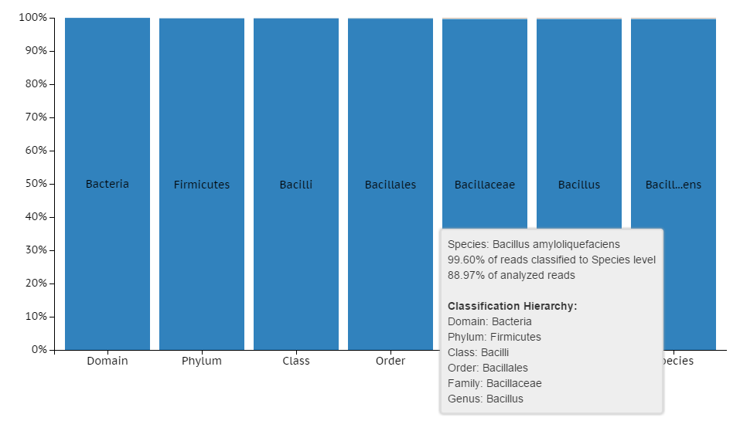
Figure 7: Taxonomic assignment of the isolate. BaseSpace identified the species to be Bacillus amyloliquefaciens based off a majority of the reads.
Number of contigs (>1,000) in assembly | Number of coding regions in assembly | 3 functional genes in the genome
1300 | 3184 | Nucleoid associated protein Cthe_2143
 |  | Uncharacterized ABC transporter ATP-binding protein Yx1F
 |  | Probable amino-acid-binding protein YxeM precursor
Table 1: Summary of genomic sequencing from BaseSpace.
Antibiotic | Inhibition zone diameter | Conclusion
Tetracycline | 18 mm | Intermediate
Amikacin | 24 mm | Susceptible
Erythromycin | 30 mm | Susceptible
Table 2: Antibiotic susceptibility results from one TSA plate.
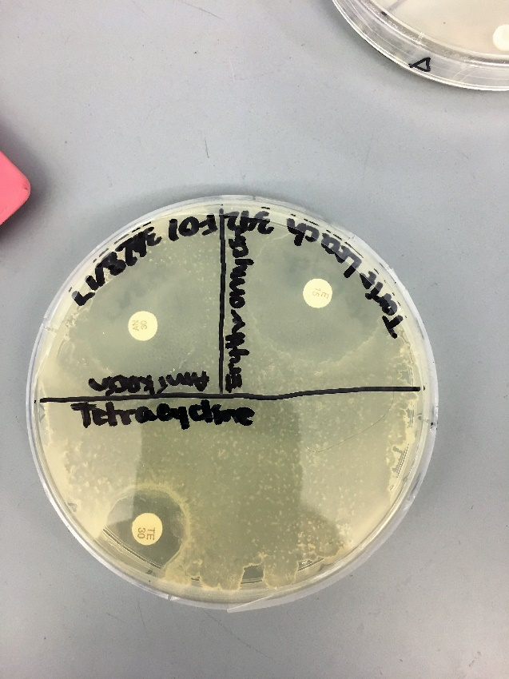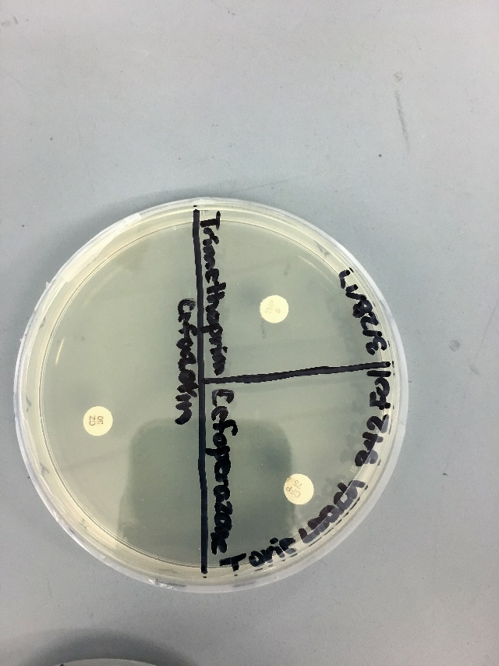
Figure 8: Antibiotic susceptibility results. Plate 1 (on left) had Tetracycline, Amikacin, and Erythromycin. Plate 2 had no growth and contained Cefazolin, Cefoperazone, and Trimethoprim.

Literature Cited
Abrahamsen, T. G., Finne, P. H., & Lingaas, E. (1989). Flavobacterium meningosepticum infections in a neonatal intensive care unit. Acta Paediatrica, 78(1), 51-55.
AlGburi, A., Volski, A., Cugini, C., Walsh, E. M., Chistyakov, V. A., Mazanko, M. S., ... & Chikindas, M. L. (2016). Safety Properties and Probiotic Potential of Bacillus subtilis KATMIRA1933 and Bacillus amyloliquefaciens B-1895. Advances in Microbiology, 6(06), 432.
Borriss, R., Chen, X. H., Rueckert, C., Blom, J., Becker, A., Baumgarth, B., ... & Junge, H. (2011). Relationship of Bacillus amyloliquefaciens clades associated with strains DSM 7T and FZB42T: a proposal for Bacillus amyloliquefaciens subsp. amyloliquefaciens subsp. nov. and Bacillus amyloliquefaciens subsp. plantarum subsp. nov. based on complete genome sequence comparisons. International journal of systematic and evolutionary microbiology, 61(8), 1786-1801.
Clark, D., Youngblood, C., Taplin, M., Brown, E., Williams, B. S., Phillips, C., & Garner, B. (2014). Impact of Iron Availability on Bacillus amyloliquefaciens Growth. Advances in Microbiology, 4(13), 962.
Dunn, R. R., Fierer, N., Henley, J. B., Leff, J. W., & Menninger, H. L. (2013). Home life: factors structuring the bacterial diversity found within and between homes. PLoS One, 8(5), e64133.
Logan, N. A., & Berkeley, R. C. W. (1984). Identification of Bacillus strains using the API system. Microbiology, 130(7), 1871-1882.
Kim, Y. S., Balaraju, K., & Jeon, Y. H. (2017). Biological characteristics of Bacillus amyloliquefaciens AK‐0 and suppression of ginseng root rot caused by Cylindrocarpon destructans. Journal of applied microbiology, 122(1), 166-179.
Mendis, H., De La Fuente, L., Schwientek, P., Salamzade, R., Thomas, V., & Kloepper, J. (2016, December). Developing a quantitative polymerase chain reaction protocol to quantitate root colonization by Bacillus amyloliquefaciens and Bacillus firmus. In PHYTOPATHOLOGY (Vol. 106, No. 12, pp. 59-59). 3340 PILOT KNOB ROAD, ST PAUL, MN 55121 USA: AMER PHYTOPATHOLOGICAL SOC.
Moffet, H. L., & Williams, T. (1967). Bacteria recovered from distilled water and inhalation therapy equipment. American Journal of Diseases of Children, 114(1), 7-12.
Molohon, K. J., Melby, J. O., Lee, J., Evans, B. S., Dunbar, K. L., Bumpus, S. B., ... & Mitchell, D. A. (2011). Structure determination and interception of biosynthetic intermediates for the plantazolicin class of highly discriminating antibiotics. ACS chemical biology, 6(12), 1307.
Monteiro, F. P., de Medeiros, F. H. V., Ongena, M., Franzil, L., de Souza, P. E., & de Souza, J. T. (2016). Effect of temperature, pH and substrate composition on production of lipopeptides by Bacillus amyloliquefaciens 629. African Journal of Microbiology Research, 10(36), 1506-1512.
Rusin, P., Orosz‐Coughlin, P., & Gerba, C. (1998). Reduction of faecal coliform, coliform and heterotrophic plate count bacteria in the household kitchen and bathroom by disinfection with hypochlorite cleaners. Journal of Applied Microbiology, 85(5), 819-828.
Soares, M. A., Li, H. Y., Bergen, M., da Silva, J. M., Kowalski, K. P., & White, J. F. (2016). Functional role of an endophytic Bacillus amyloliquefaciens in enhancing growth and disease protection of invasive English ivy (Hedera helix L.). Plant and Soil, 405(1-2), 107-123.
Tan, S., Gu, Y., Yang, C., Dong, Y., Mei, X., Shen, Q., & Xu, Y. (2016). Bacillus amyloliquefaciens T-5 may prevent Ralstonia solanacearum infection through competitive exclusion. Biology and Fertility of Soils, 52(3), 341-351.
Zhang, N., Yang, D., Kendall, J. R., Borriss, R., Druzhinina, I. S., Kubicek, C. P., ... & Zhang, R. (2016). Comparative genomic analysis of Bacillus amyloliquefaciens and Bacillus subtilis reveals evolutional traits for adaptation to plant-associated habitats. Frontiers in Microbiology, 7.

