Courtney Cox
4/28/17
Isolating and identifying bacterium from hockey glove
Introduction
Life would not be possible without the existence of microorganisms; they affect every living thing on Earth and can be found anywhere you look. One of those places is on the human body. Even though there has been many recent advances in understanding the human microbiome, there have been no inclusive reviews in hand microbiome research (Edmond-Wilson 2015). According to a database search on skin microbiome-related articles that were published between 2008 and 2015, eighteen articles contained information on the hand microbiome, identifying the four most common bacterial phyla’s present: Firmicutes, Actinobacteria, Proteobacteria, and Bacteroidetes (Edmond-Wilson 2015).
The most common bacteria found in athletic gear are related to skin infections like Staphylococcus aureus, Tinea corporis and capitis, and Leptospirosis spp. (Grosset-Janin 2012). The most dangerous skin infection is methicillin-resistant S. aureus (MRSA) because of its virulence and resistance to conventional treatments (Beavis 2008). Localized bacterial infections are also common among athletes and some environmental bacteria can also appear from exposure to wet areas. The goal of this experiment is to isolate, characterize, and identify a bacterium swabbed from a hockey glove.
My hypothesis is that some form of Staphylococcus will be present on the hockey glove. I predict that Staphylococcus will be present because it is very common among sport teams, especially when that sport requires safety equipment. There is also a strong possibility that a microbe not commonly found in a hockey glove can be isolated, especially if the microbe is still getting the nutrients it needs to survive, like oxygen or a carbon source. This is a good possibility because the human hand is exposed to many objects and environments throughout the day, and if a microbe is stuck on the hand and is then stuffed into the glove, there’s a good chance of the microbe transferring onto the glove.
Materials and Methods
Inoculation and Isolation of Bacterium
First, I used a sterile swab to swab the inside of my hockey glove then used that swab to inoculate a sterile Tryptic Soy Agar (TSA) plate. After inoculating the plate, I closed it, making sure oxygen was still available, and stored it in a dark and warm (21°C) location. I allowed the bacteria to grow over the next week while recording any observations.
After the week was up, I began to isolate my bacterium. To do this, I selected a round, shiny, cream colored colony, as seen in figure 1, from the TSA plate I inoculated and used aseptic technique to transfer that colony to a new TSA plate using the streak plate method as stated in the Lab 2B Handout. I then allowed this plate to grow for a few days in the incubator, which was set to 37°C. I then repeated this step two more times to make a total of three streak plates to insure that the bacterium I was targeting was isolated.
Staining and Morphology
Next, a Gram stain was performed (Lab 4 Handout) to determine if the isolate was Gram negative or Gram positive. During this time I also observed the isolate under a microscope to determine and note the cell morphology (rods, cocci, etc.) and colony morphology (color, size, shape).
DNA Extraction and Analysis
After inoculating a liquid Tryptic Soy Broth (TSB) culture and letting it grow, I extracted the DNA from the isolate using the PowerSoil DNA extraction kit and following the protocol provided in the Lab 5 Handout. The kit used allowed cell lysis to break open the cells by bead beating and adding sodium dodecyl sulfate (SDS), which released the DNA from the cell. The kit also purified the DNA by removing inhibitors and proteins. After extracting the DNA, a sample of it was sent to the UAF DNA Core Lab to sequence the genome using an Illumina MiSeq.
Physiological Tests
While waiting for the DNA sequencing results, I moved on to test for physiological traits. The physiological tests that I conducted were the: Fluid Thioglycollate test (determines oxygen class), Oxidase test (determines if the strain has cytochrome c oxidase; distinguishes between pseudomonad species and enteric species), Catalase test (determines of the strain has catalase, which catalyzes the release of O₂ from reactive oxygen species), and the API-20 E test strip. The test strip tested the abilities of the isolate to ferment glucose, lactose and mannitol, as well as other physiological abilities as described in the Lab 6 Handout.
Genomic Analysis
Once the genome sequencing was done I used Base Space Ilumina to perform the bioinformatics analysis using the protocol provided in the Lab 7 Handout. This allowed me to taxonomically identify my isolate and to identify the functional genes within. SPAdes Genome Assembler was used to assemble the genome of my isolate and Kraken metagenomics was used to identify my isolate to the species and genus levels.
Antibiotic Testing
The susceptibility of the isolate to antibiotics was then assessed according to the protocols provided in the Lab 9 Handout. The specific antibiotics tested were Cefazolin, Clindamycin, Gentamicin, Oxacillin, Piperacillin, Trimethoprim, Erythromycin, and Tetracycline. This allowed me to identify what antibiotics could be used to treat my bacterium.
Results
The species that was assigned to my isolate was Bacillus cereus with a 93.39% confidence level (Fig. 2). 1,344 contigs were obtained from the isolate with the longest contig being 84,168 bp long. The total length of the genome that was assembled was 6,084,234 bp and the guanines and cytosine percent (GC%) was 35.18% (Fig. 3).
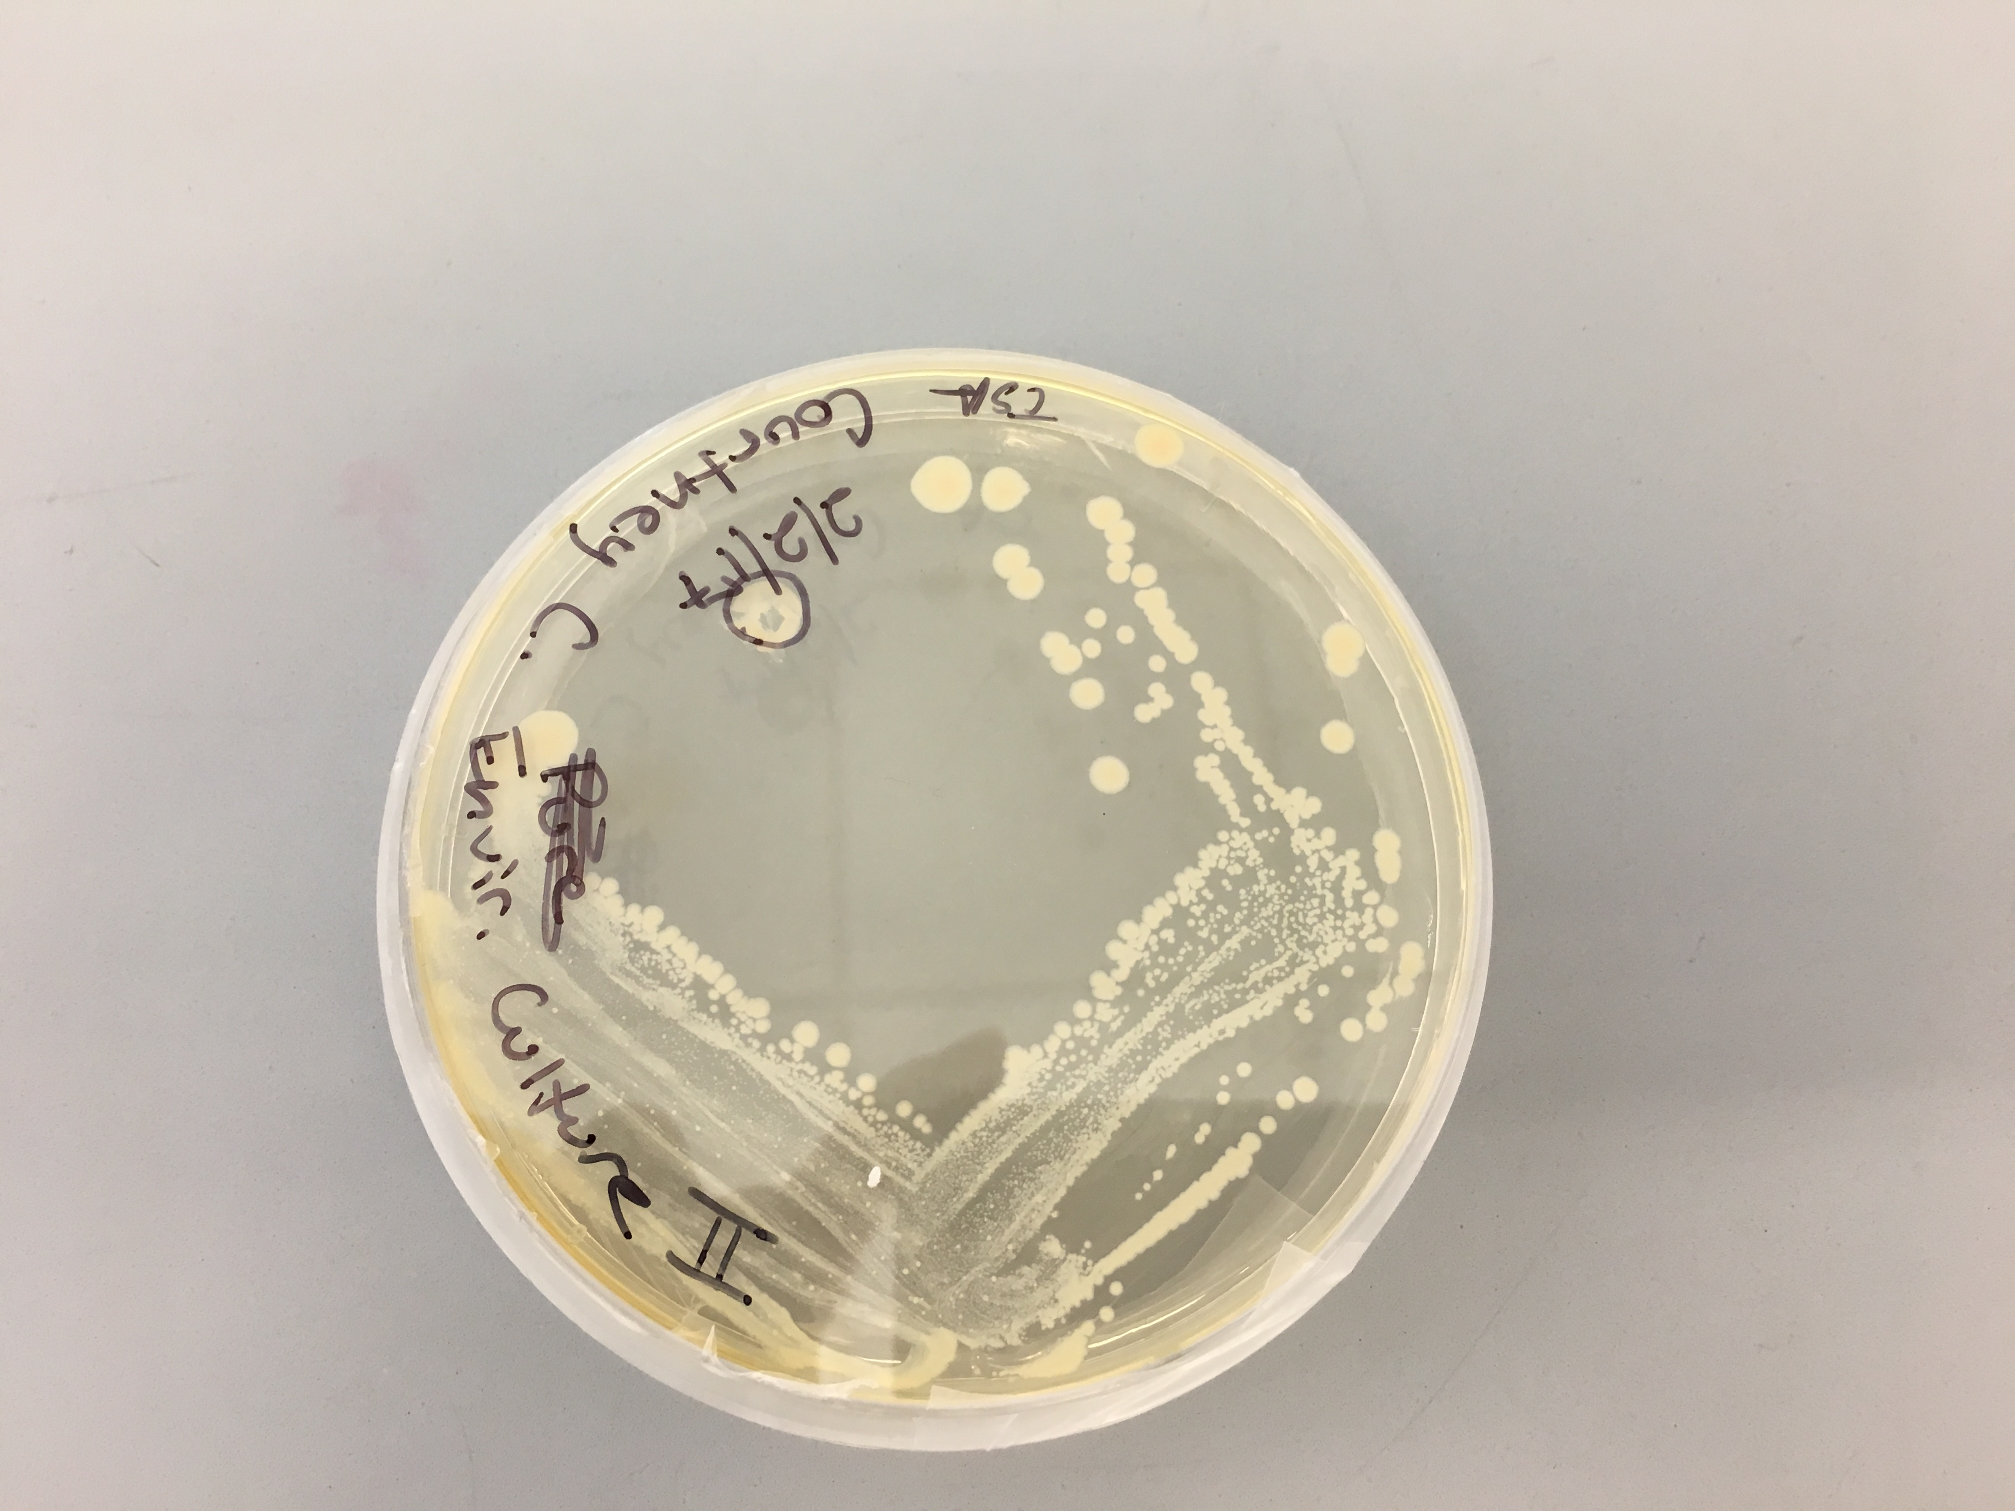
Figure 1. Targeted colony of B. cereus on TSA plate.
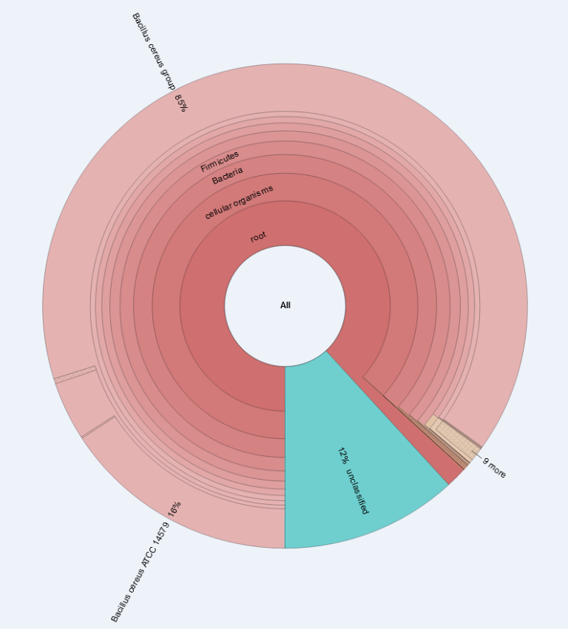
Figure 2. Percentage of species found in isolate, revealed that 85 percent of the isolate is Bacillus cereus.
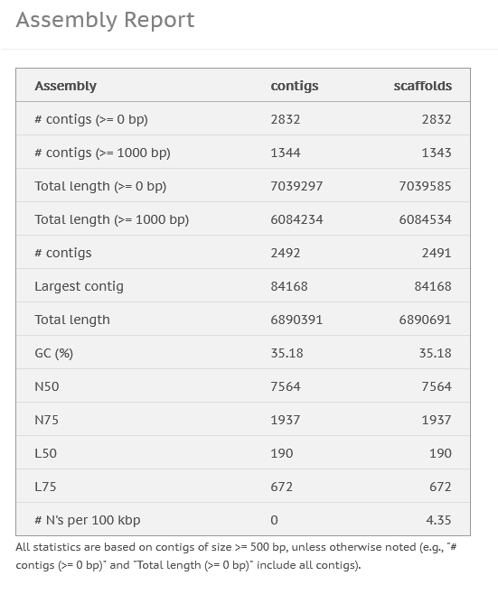
Figure 3. Overall results for genome assembly.
Table 1. Tests used to help determine the species of the isolate.
Test | Result | Reaction
Gram Stain | Gram-positive | Gram classification
Fluid Thioglycollate Test | Strict Aerobe | Determined oxygen class
Oxidase Test | Positive | Distinguish between pseudomonad and enteric species
Catalase Test | Negative | Determined if isolate can catalyze the release of O₂ from H₂O₂
API 20 Strep Test Strip
VP | Positive | Acetoin Production
ESC | Positive | Esculin Hydrolysis
ADH | Positive | Arginine Dihydrolase
ARA | Positive | Arabinose Fermentation
MAN | Positive | Mannitol Fermentation
LAC | Positive | Lactose Fermentation
TRE | Positive | Trehalose Fermentation

The fluid thioglycollate test determined that the isolate is a strict anaerobe because it only grew in the oxic zone of the test tube over a 7-day period (Table 1). The oxidase test determined that the isolate has cytochrome c oxidase, which distinguishes it as a pseudomonad species (Table 1). The ESC and ADH tests from the API 20 Strep test strip determined that the isolate can use esculin and arginine, respectively, as a carbon source (Table 1). Last, the ARA, MAN, LAC, and TRE test determined what compounds the isolate can ferment (Table 1).
Table 2. Antibiotics used to assess susceptibility or resistance of isolate.
Antibiotic | Zone Diameter Length (mm) | Resistance/Susceptibility
Erythromycin | 28 mm | Susceptible
Gentamicin | 32 mm | Susceptible
Clindamycin | 25 mm | Susceptible
Piperacillin | 39 mm | Susceptible
Tetracyclin | 34 mm | Susceptible
Cefazolin | 32 mm | Susceptible
Oxacillin | 20 mm | Susceptible
Trimethoprim | 24 mm | Susceptible

The disk diffusion test identified the antibiotic susceptibility and resistance capabilities of the isolate. The results of this test were that the isolate was susceptible to all eight of the antibiotics that were tested (Table 2).
Discussion
My hypothesis that a Staphylococcus species would be isolated from the hockey glove was not supported. Instead, the microbe that was isolated is Bacillus cereus with a 93.39% confidence level (Fig. 2). B. cereus is a Gram-positive aerobe that is a spore-forming rod (Drobniewski 1993). This is consistent with the experiment results for the fluid thioglycollate test, Gram stain, and morphology (Table 1). The colony appearance of smooth, circular, and moist colonies that are cream in color, as seen in figure 1, is also consistent with the literature description of B. cereus (Vos 2011). According to the results, B. cereus can ferment arabinose, mannitol, lactose, and trehalose (Table 1). This means that the microbe can use those compounds as a carbon source for fermentation. The results also indicate that the isolate can us esculin and arginine as a carbon source and an energy source, as well as produce acetoin (Table 1). The results from the study that is consistent with the literature on B. cereus is the acetoin production, esculin hydrolysis, arginine dihydrolase, and trehalose fermentation (Vos 2011). The oxidase test result was not consistent with a B. cereus colony that was isolated in a different study, the oxidase result for that experiment was negative (Valero 2002). The catalase and lactose fermentation test results were also not consistent with literature reported colonies of B. cereus, the results for the literature colony was catalase-positive and lactose fermentation-negative (Vos. 2011). The discrepancy with the literature is most likely the result of continuing to test my streak plate IV, even though it was known that the plate had been contaminated.
When it comes to antibiotics, B. cereus is mostly resistant to penicillins and cephalosporins, but there have been some reports of resistance to erythromycin, tetracycline, and carbapenem (Bottone 2010). This is not consistent with the susceptibility or resistance results of this study (Table 2). According to the antibiotic susceptibility testing in this experiment the isolate B. cereus is susceptible to both erythromycin and tetracycline (Table 2). This could be a result of only some B. cereus strains being resistant to erythromycin and tetracycline. In the aforementioned reported cases of resistance, the bacterium could have developed a resistance to the antibiotic via horizontal gene transfer.
B. cereus is most commonly known for food poisoning and can be found and isolated from most soils and plants, as well as foods like raw meat and vegetables (Valero 2002). This is what makes it odd that B. cereus was isolated from a hockey glove. One possibility for how this happened is that the microbe was transferred to the glove from my hand and it was able to survive in the atypical environment.

Literature Cited
Beavis, R. C., & MacDonald, P. B. (2008). Staphylococcus aureus Septicemia Secondary to Hand Abrasions in a Professional Hockey Player-A Case Report. Clinical Journal of Sport Medicine, 18(2), 174-175.
Bottone, E. J. (2010). Bacillus cereus, a volatile human pathogen. Clinical microbiology reviews, 23(2), 382-398.
Drobniewski, F. A. (1993). Bacillus cereus and related species. Clinical microbiology reviews, 6(4), 324-338.
Edmonds-Wilson, S. L., Nurinova, N. I., Zapka, C. A., Fierer, N., & Wilson, M. (2015). Review of human hand microbiome research. Journal of dermatological science, 80(1), 3-12.
Grosset-Janin, A., Nicolas, X., & Saraux, A. (2012). Sport and infectious risk: a systematic review of the literature over 20 years. Médecine et maladies infectieuses, 42(11), 533-544.
Valero, M., Hernández-Herrero, L. A., Fernández, P. S., & Salmerón, M. C. (2002). Characterization of Bacillus cereus isolates from fresh vegetables and refrigerated minimally processed foods by biochemical and physiological tests. Food Microbiology, 19(5), 491-499.
Vos, P., Garrity, G., Jones, D., Krieg, N. R., Ludwig, W., Rainey, F. A., ... & Whitman, W. (Eds.). (2011). Bergey's Manual of Systematic Bacteriology: Volume 3: The Firmicutes (Vol. 3). Springer Science & Business Media, 20-93.

